Care Coordination (CC)

Standardized Episodes of Care (SEOC)

Software Version 1.9

User Guide



September 2019

Department of Veterans Affairs

Office of Information and Technology (OI&T)

Revision History

NOTE: The revision history cycle begins once changes or enhancements are requested after the document has been baselined.

| Date | Revision | Description | Author |
| --- | --- | --- | --- |
| 9/18/2019 | 7.0 | Updated for v1.9:   * Updated screen captures. * Added section: Export the SEOC Data to a JSON File. * Added section: Export the SEOC PreCert Data to a JSON File. * Added section: Sort SEOCs Alphabetically by Name. * Added section: Invalid Characters. * Added section: Show Invalid Characters. * Added section: Fix Invalid Characters. * Added section: Revert a Date Hold SEOC back to In-Progress. * Updated definitions for the Standardized Episodes of Care table fields. * Updated the steps in the JSON Instructions section. | AbleVets |
| 06/11/2019 | 6.0 | Updated for v1.8:   * Draft New SEOC section * Activate an In-Progress SEOC section * Delete an In-Progress SEOC section * Revert SEOC to In-Progress section | AbleVets |
| 3/05/2019 | 5.0 | Updated for v1.7. Added Managing Billing Codes, Updated screen captures to reflect v1.7 | AbleVets |
| 1/02/2019 | 4.0 | Updated for v1.6 Updated screen captures, Added Exporting SEOC Data section, added Appendix A. | AbleVets |
| 10/04/2018 | 3.0 | Updated for v1.5 Included Manage Users features: Filter by Role, Filter by Name, Delete Selected User, Edit Selected User, and Add New User. | AbleVets |
| 09/25/2018 | 2.0 | Finalized for Software Version 1.0.04.1 | AbleVets |
| 09/14/2018 | 1.3 | Finalized for Build 5 | AbleVets |
| 08/09/2018 | 1.2 | Updated for Build 5 | AbleVets |
| 07/20/2018 | 1.1 | Updated for Software Version 1.0.4 Build 4 | AbleVets |
| 06/25/2018 | 1.0 | Initial Draft Delivery | AbleVets |

**Artifact Rationale**

Per the Veteran-focused Integrated Process (VIP) Guide, the User’s Guide is required to be completed prior to Critical Decision Point #2 (CD2), with the expectation that it will be updated as needed. A User Guide is a technical communication document intended to give assistance to people using a particular system, such as VistA end users. It is usually written by a technical writer, although it can also be written by programmers, product or project managers, or other technical staff. Most user guides contain both a written guide and the associated images. In the case of computer applications, it is usual to include screenshots of the human-machine interfaces, and hardware manuals often include clear, simplified diagrams. The language used is matched to the intended audience, with jargon kept to a minimum or explained thoroughly. The User Guide is a mandatory, build-level document, and should be updated to reflect the contents of the most recently deployed build. The sections documented herein are required if applicable to your product.

**Table of Contents**

1. Introduction 1

1.1. Purpose 1

1.2. Document Orientation 1

1.2.1. Organization of the Manual 1

1.2.2. Assumptions 2

1.2.3. Coordination 2

1.2.4. Disclaimers 3

1.2.4.1. Software Disclaimer 3

1.2.4.2. Documentation Disclaimer 3

1.2.5. Documentation Conventions 3

1.2.6. References and Resources 3

1.3. National Service Desk and Organizational Contacts 3

2. System Summary 3

2.1. System Configuration 4

2.2. Data Flows 5

2.3. User Access Levels 5

2.4. Continuity of Operation 6

3. Getting Started 6

3.1. Logging On 6

3.2. System Menu 7

3.3. Changing User ID and Password 8

3.4. Exit System 8

4. Using the Software 8

4.1. Manage Users 9

4.1.1. Viewing SEOC Users 9

4.1.1.1. Filtering Users 9

4.1.2. Delete a Selected User 10

4.1.3. Edit a Selected User 11

4.1.4. Add a New User 11

4.2. Export the SEOC Data to a JSON File 12

4.3. Export the SEOC PreCert Data to a JSON File 13

4.4. Managing Billing Codes 13

4.4.1. Deleting Billing Codes 14

4.4.2. Editing Billing Codes 15

4.5. View SEOCs 17

4.5.1. View a Selected SEOC 17

4.5.2. Search for a SEOC by Name 17

4.5.2.1. Sort SEOCs Alphabetically by Name 18

4.5.3. Filter SEOCs by Status 20

4.5.4. Discontinue a SEOC 20

4.5.5. Print a SEOC 21

4.5.6. Invalid Characters 22

4.5.6.1. Show Invalid Characters 23

4.5.6.2. Fix Invalid Characters 25

4.5.7. Track Version Changes 26

4.6. Draft a New SEOC 30

4.6.1. Edit an In-Progress SEOC 42

4.6.2. Activate an In-Progress SEOC 43

4.6.3. Delete an In-Progress SEOC 46

4.7. Pending Revisions 46

4.7.1. Create a Pending Revision 46

4.7.2. Activate a Pending Revision 50

4.7.3. Revert a Date Hold SEOC back to In-Progress 53

4.8. Payable Service List 53

4.8.1. View Payable Services 53

4.8.2. Delete Payable Service 54

5. Troubleshooting 56

6. Acronyms and Abbreviations 56

A. JSON Instructions 57

List of Figures

Figure 1: Overview of SEOC System 4

Figure 2: SEOC Data Flow Diagram 5

Figure 3: VA Single Sign-On for SEOC 6

Figure 4: 2 Minutes Until Session Expires Warning 7

Figure 5: Standardized Episodes of Care Home Page 7

Figure 6: User Management 9

Figure 7: Filtered List by Name Example 10

Figure 8: Delete Selected User Confirmation 11

Figure 9: Editable User Fields 11

Figure 10: Add New User Fields 12

Figure 11: Export SEOC Data 12

Figure 12: Export SEOC Data Dialog 13

Figure 13: Export SEOC Data 13

Figure 14: Export SEOC PreCert Data Dialog 13

Figure 15: Billing Code Management 14

Figure 16: Confirm Delete Billing Code Message 14

Figure 17: Billing Code Deletion Confirmation Message 15

Figure 18: Edit Billing Code 16

Figure 19: Edit Billing Code Confirmation Message 16

Figure 20: View SEOC 17

Figure 21: SEOC Filter Field 17

Figure 22: Search SEOC Results 18

Figure 23: SEOC Name Column Heading 18

Figure 24: SEOC List Sorted in Alphabetical Order by Name 19

Figure 25: SEOC List Sorted in Reverse Alphabetical Order by Name 19

Figure 26: Filter by Status Menu Options 20

Figure 27: Discontinue SEOC Confirmation 20

Figure 28: Discontinued Status 21

Figure 29: Printed SEOC Window 22

Figure 30: Show Invalid Characters Button 23

Figure 31: Show Invalid Characters 23

Figure 32: Print SEOC from Show Invalid Characters Page 24

Figure 33: Print SEOC from Show Invalid Characters (Bottom of the Page) 24

Figure 34: Hide Invalid Characters Button 25

Figure 35: Fix Invalid Characters Button 25

Figure 36: Fix Invalid Characters Confirmation 26

Figure 37: Invalid Characters Fixed Message 26

Figure 38: Track Version Changes Page 27

Figure 39: Track Version Changes: Additional Information and Provider Taxonomy Codes 27

Figure 40: Track Version Changes: Payable Services 28

Figure 41: Print SEOC from Track Version Changes Page 28

Figure 42: Print SEOC from Track Version Changes: Additional Information and Provider Taxonomy Codes 29

Figure 43: Print SEOC from Track Version Changes: Payable Services 29

Figure 44: Draft SEOC: Name 30

Figure 45: Draft SEOC Details 31

Figure 46: Add/Remove HPTCs 32

Figure 47: Provider Taxonomy Code List 32

Figure 48: Draft SEOC: Provider Taxonomy Code Added Message 33

Figure 49: Draft SEOC: Added Provider Taxonomy Codes 34

Figure 50: Draft SEOC: Confirm Remove HPTC 34

Figure 51: Draft SEOC: Payable Services 35

Figure 52: Draft SEOC: Add Payable Service 35

Figure 53: Draft SEOC: Add Clinical Service 36

Figure 54: Draft SEOC: Clinical Service Added Message 37

Figure 55: Draft SEOC: New Clinical Services Added to the Payable Service 37

Figure 56: Draft SEOC: Add Billing Code 38

Figure 57: Draft SEOC: Billing Code Added Message 38

Figure 58: Define New Code 39

Figure 59: Draft SEOC: New Billing Code Added Message 40

Figure 60: Duplicate Billing Code Message 40

Figure 61: Draft SEOC: Billing Codes Added to the Payable Service 40

Figure 62: Draft SEOC: Payable Service Added to SEOC 41

Figure 63: Draft SEOC: Delete Payable Service Confirmation 41

Figure 64: Draft SEOC View 42

Figure 65: Draft SEOC: View Provider Taxonomy Codes and Payable Services 42

Figure 66: SEOC Activation Errors 43

Figure 67: SEOC Activation Confirmation 44

Figure 68: SEOC Activation Confirmation Calendar 44

Figure 69: SEOC Will be Activated Message 45

Figure 70: Date Hold Status 45

Figure 71: Confirm Deletion 46

Figure 72: Pending Revision: Name 47

Figure 73: Pending Revision: Details 47

Figure 74: Pending Revision: SEOC Provider Taxonomy Codes 48

Figure 75: Pending Revision: Payable Services 49

Figure 76: Pending Revision Status 49

Figure 77: Pending Revision Displayed in SEOC List 50

Figure 78: Revision Activation Errors 50

Figure 79: Pending Revision Activation Confirmation Message 51

Figure 80: Revision Activation Confirmation Date Calendar 51

Figure 81: Revision Will be Activated Message 52

Figure 82: Date Hold Status 52

Figure 83: Confirm Revert SEOC to In-Progress 53

Figure 84: View SEOC – Payable Services 54

Figure 85: Payable Service Confirm Deletion 55

Figure 86: Import Data Window 57

Figure 87: Query Editor 58

Figure 88: List of Records 58

Figure 89: To Table Dialog Box 59

Figure 90: Search Columns to Expand Dialog Box 59

Figure 91: Search Columns to Expand 60

Figure 92: Expanded SEOC Fields 61

Figure 93: Expand to New Rows Menu Option 61

Figure 94: Payable Services Columns 62

Figure 95: Billing Code Columns 62

Figure 96: Expanded HPTC Fields 63

Figure 97: Imported Data 63

# Introduction

The Care Coordination (CC) Standardized Episodes of Care (SEOC) is a reference database for managing care bundles for use by Veterans Information Systems and Technology Architecture (VistA) and other Department of Veterans Affairs (VA) systems. Services are grouped together within the SEOC system into bundles so that clinicians can add these bundles to patients consult records in a standardized fashion, reducing the amount of time spent manually entering consult instructions, and providing uniformity among the patient records and across facilities for how patient care is prescribed for similar complaints.

These bundles group together one or more services that are preselected for different specialties to be added to the consult records. In addition, the clinician is provided with information regarding prescribing rules and preauthorization requirements, so they can make the most informed decisions regarding patient care.

Additionally, SEOC data will be accessible outside of the VistA/Computerized Patient Record System (CPRS) system so that users of downstream applications will be accessing the centralized data, and SEOC descriptions, reducing the chances of disconnects.

## Purpose

The purpose of this document is to provide instruction for utilizing the SEOC application to standardize and streamline consult management for Community Care.

## Document Orientation

The *Care Coordination (CC) Standardized Episodes of Care (SEOC) v1.9 User Guide* will provide explanations of each screen and of all user interface options within the context of an easy to understand demonstration data scenario.

This document is also designed to provide the user with screen-by-screen “how to” information on the usage of CC SEOC.

### Organization of the Manual

**Section 1: Introduction**

The Introduction section provides the purpose of this manual, an overview of the SEOC software, an overview of the software used, project references, contact information for the user to seek additional information, and an acronyms and abbreviations list for this manual.

**Section 2: System Summary**

The System Summary section provides a graphical representation of the equipment, communication, and networks used by the system, user access levels, how the software will be accessed, and contingencies and alternative modes of operation.

**Section 3: Getting Started**

Information for the Getting Started section provides a general walk-through of the system from initiation through exit, enabling the user to understand the sequence and flow of the system.

**Section 4: Using the Software**

This section gives the user the “how to” information to use SEOC, including many step-by-step procedures.

**Section 5: Troubleshooting**

This section provides troubleshooting for the SEOC user.

**Section 6: Acronyms and Abbreviations**

This section provides a list of acronyms and abbreviations found in this document.

### Assumptions

This guide was written with the following assumed experience/skills of the audience:

* The SEOC user has basic knowledge of the SEOC system (such as the use of commands, menu options, and navigation tools).
* The SEOC user has been provided the appropriate active roles, menus, and security keys required for the SEOC User Interface (UI), as defined below in User Roles.
* The SEOC user is using SEOC to perform their daily consult creation workflow and perform the required SEOC functions.
* The SEOC user has validated access to the SEOC UI.
* The SEOC user has been provided training on the SEOC UI and has reviewed the User Guide.
* SEOC Content Authors: The SEOC Content Authors are responsible for creating and update the content within the SEOC repository using the SEOC UI. These users are required to VA access rights and privileges and will sign on to the SEOC application using their SSOI credentials (typically their PIV and access code).
* CPRS Clinicians that are responsible for documenting patient consult records. These clinicians utilize the SEOC content as part of their daily consult creation workflow such that they will add a SEOC bundle to the patient consult record which will provide for a standardized documentation and care plan approach across the VA for these consults.

### Coordination

One Consult - Consult Toolbox 1.9.02 and above and the HealthShare Referral Manager (HSRM) depend on the availability of the SEOC System. Consult Toolbox 1.9.02 requires active SEOCs whereas HSRM requires active and discontinued SEOCs. Coordination between the One Consult – Consult Toolbox, HSRM, and SEOC team is necessary with any updates to SEOC.

### Disclaimers

#### Software Disclaimer

This software was developed at the Department of Veterans Affairs (VA) by employees of the Federal Government in the course of their official duties. Pursuant to title 17 Section 105 of the United States Code this software is not subject to copyright protection and is in the public domain. VA assumes no responsibility whatsoever for its use by other parties, and makes no guarantees, expressed or implied, about its quality, reliability, or any other characteristic. We would appreciate acknowledgement if the software is used. This software can be redistributed and/or modified freely provided that any derivative works bear some notice that they are derived from it, and any modified versions bear some notice that they have been modified.

#### Documentation Disclaimer

The appearance of external hyperlink references in this manual does not constitute endorsement by the Department of Veterans Affairs (VA) of this Web site or the information, products, or services contained therein. The VA does not exercise any editorial control over the information you may find at these locations. Such links are provided and are consistent with the stated purpose of the VA.

### Documentation Conventions

This manual uses several methods to highlight different aspects of the material.

Table 1. Documentation Symbols and Descriptions

|  |  |
| --- | --- |
| Symbol | Description |
| Triangle with an exclamation point (!) inside to indicate caution for the reader to take special notice of critical information. | **CAUTION:** Used to caution the reader to take special notice of critical information. |

1. Notes are used to inform the reader of general information including references to additional reading material.

### References and Resources

Readers who wish to learn more about CPRS and CC SEOC should consult the [VA Software Document Library](https://www.va.gov/vdl/).

## National Service Desk and Organizational Contacts

For issues related to the CC SEOC that cannot be resolved by this manual or the site administrator, please contact the National Service Desk at 855-NSD-HELP (673-4357).

# System Summary

There was an immediate need to provide clinicians the ability to quickly and consistently add care bundles to a patient’s consult record within VistA. SEOC provides this feature for a higher level of uniformity in patient care, easier access to appropriate services, based on initial diagnoses, and the ability to better control care costs. SEOC allows clinicians to enhance the coordination of care for the Veteran.

The system contains SEOCs, or care bundles, that clinicians or other designated individuals can assign to VA patients. These bundles allow for the consistent use of procedures when certain conditions are diagnosed. This consistency allows the VA to effectively manage patient care and provides easier traceability.

## System Configuration

The SEOC System is designed to be a simple reference database with a supporting SEOC API and User Interface (UI) layer. The SEOC system comprises three application tiers as shown below.

Figure 1: Overview of SEOC System

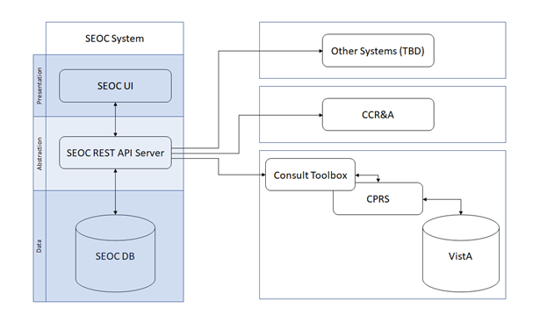

The first tier is the Data Tier. This tier contains SEOC data. SEOC uses Microsoft Structured Query Language (SQL) Server is the database. SEOC data consists of reference data, such as SEOC name, associated procedures, associated Current Procedural Terminology (CPT) codes, procedure durations, etc. Additionally, user role information is maintained within the tables, but no passwords or other credentials are stored. No PHI or PII is stored in the database. SEOC data is associated with patient data in the VistA consult record.

The second tier is the Abstraction Tier. This tier acts as the data broker for the SEOC system. It is a REST Application Programming Interface (API), built as a microservice hosted on container infrastructure (Docker Container). The API itself is built on the Spring MVC framework. The API receives web API calls that are forwarded to the database appropriately. Consuming applications are able to query the SEOC system through the SEOC REST API but will not be able to perform updated operations. The SEOC UI uses certificates to authenticate with the SEOC REST API to allow data modification within the SEOC system by authenticated users. Users are authenticated using SSOI. Additionally, a VistA/MUMPS patch is created to insert the SEOC associations into File # 123.

The third and final tier is the Presentation Tier. This tier consists of the SEOC UI, which provides a user interface for approved, authenticated users to maintain the SEOC collection. This application is a web application built as a microservice hosted on container infrastructure (Docker Container). The UI is built using the React.js JavaScript framework for web applications.

## Data Flows

Figure 2: SEOC Data Flow Diagram

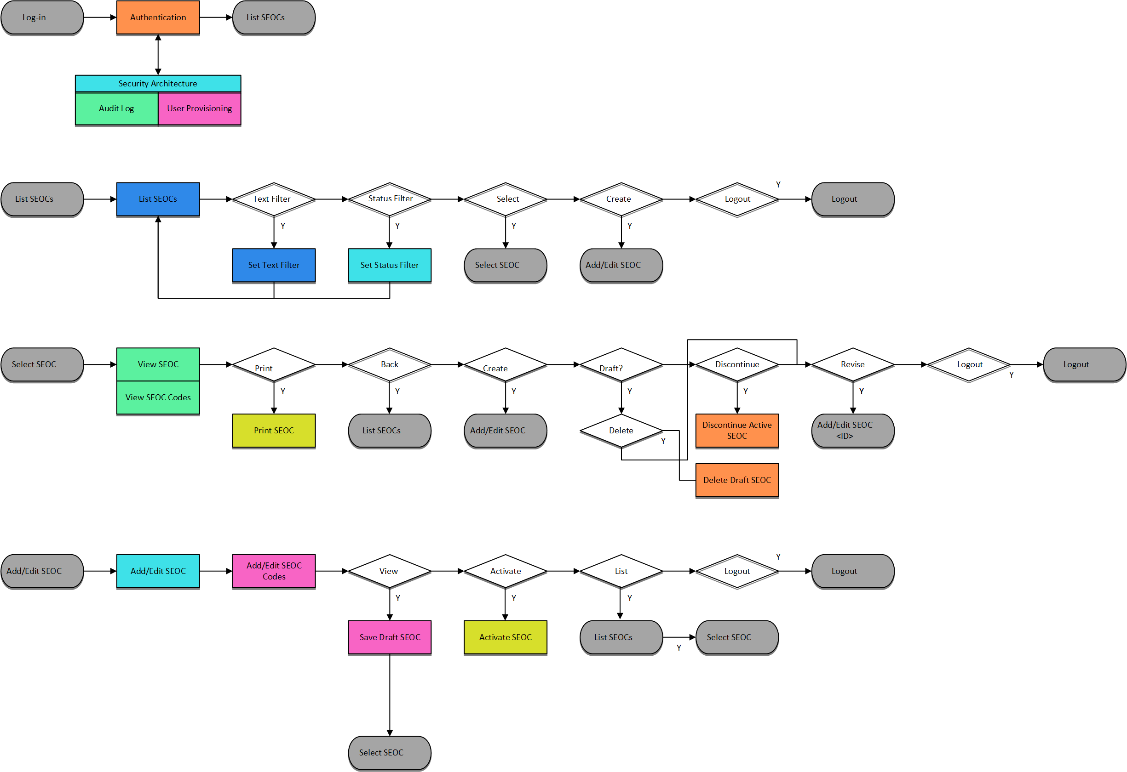

## User Access Levels

SEOC user profiles comprise of the following “types of users”:

* SEOC Content Authors: The SEOC Content Authors are responsible for creating and update the content within the SEOC repository using the SEOC UI. These users are required to VA access rights and privileges and will sign on to the SEOC application using their SSOI credentials (typically their PIV and access code).
* CPRS Clinicians that are responsible for documenting patient consult records. These clinicians utilize the SEOC content as part of their daily consult creation workflow such that they will add a SEOC bundle to the patient consult record which will provide for a standardized documentation and care plan approach across the VA for these consults.
* SEOC data is also accessible to other external consumers in the future (in addition to CPRS users). The SEOC API is a RESTFul API that other (to be determined) users will have access to use.

## Continuity of Operation

The SEOC system is maintained by Enterprise Operations (EO). The continuity of operations is managed by EO.

# Getting Started

This section provides a general walkthrough of CC SEOC from initiation through exit.

## Logging On

CC SEOC is accessed using the VA Single Sign-On Internal (SSOi) log in using the following URL: <https://seoc.va.gov/>

Figure 3: VA Single Sign-On for SEOC

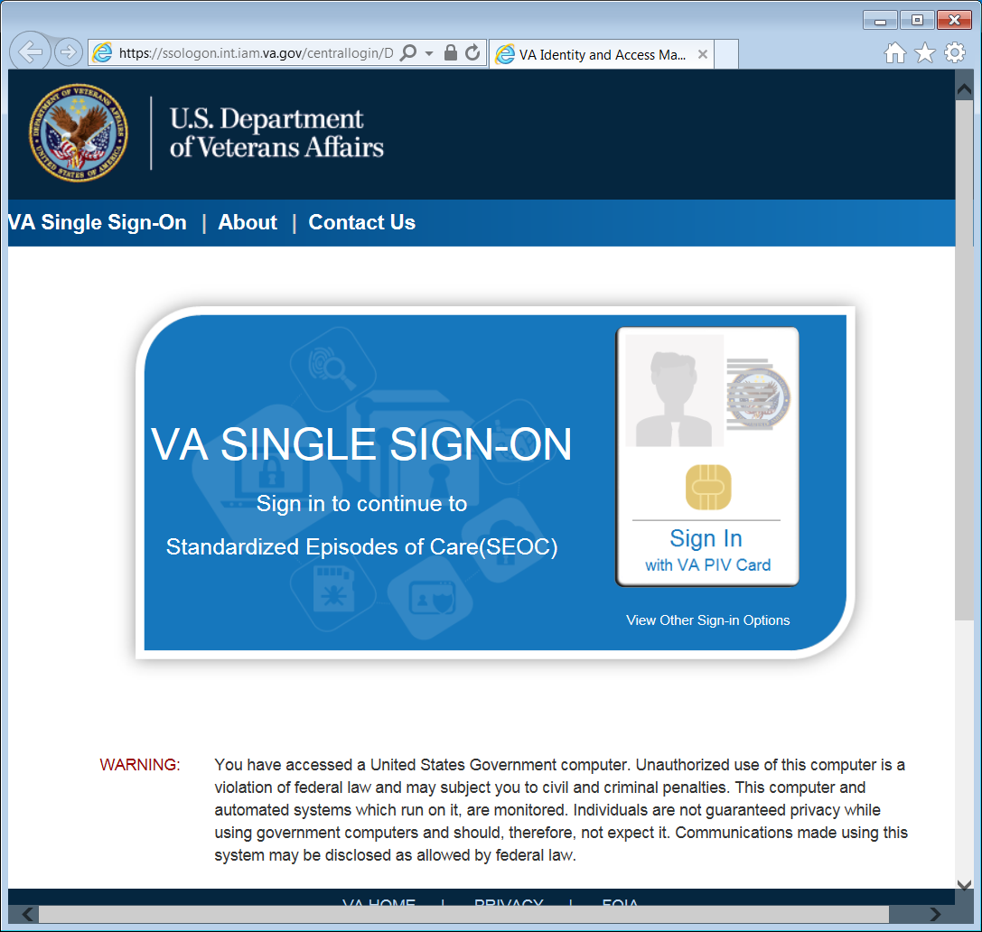

1. After 15 minutes of inactivity the system will automatically log you out. After 13 minutes of inactivity the system will prompt you to extend your session.

Figure 4: 2 Minutes Until Session Expires Warning

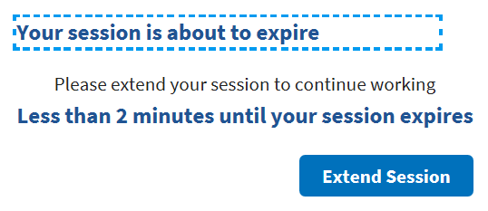

## System Menu

The Standardized Episodes of Care home page offers seven features: **Filter by Status**, **Filter by Name**, **Manage Users**, **Export SEOC Data**, **Manage Billing Codes**, **View Selected SEOC**, and **Draft New SEOC**. The home page also displays the user name at the top right of the page.

Figure 5: Standardized Episodes of Care Home Page

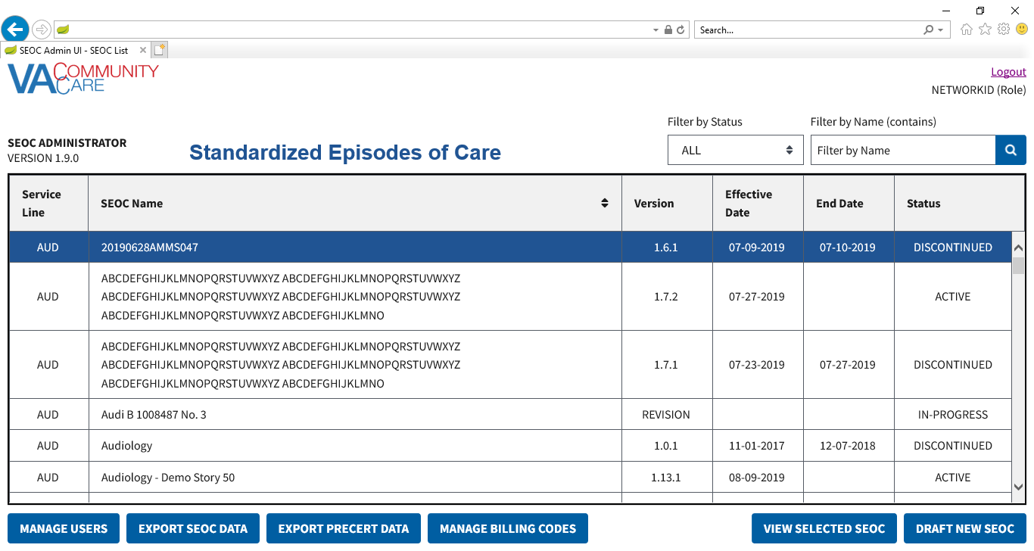

Standardized Episodes of Care table fields:

* **Service Line** – A broad category of care for the services and procedures included which is intended to be used to group and filter SEOCs for easier accessibility. A standardized three-letter abbreviation of the service line is included at the beginning of the SEOC ID.
* **SEOC Name** – A unique title that categorizes a SEOC by specialty/subspecialty or area of clinical practice.
* **Version** – The version number of the SEOC. The version number is formatted A.B.C where the first digit will be 1, the second digit is the number of published SEOCs in the same Category of Care when a new SEOC is activated, and the third digit is a serialized revision number.
* **Effective Date** –The date the SEOC status was made from In-Progress to Active.
* **End Date** –The date the SEOC status was discontinued.
* **Status** –The SEOC statuses are as follows:
* **Active**: When a SEOC is Active, it will be available for all end users (e.g. API users, scheduling, payment, and auditing purposes).
* **Date Hold**:When the SEOC status is Date Hold, it is pending and set for activation on a designated future date. This status is only available for SEOC Administrative users for editing purposes.
* **Discontinued**:When a SEOC is Discontinued, read-only users will not have access to the discontinued SEOC in the SEOC Database ~~and~~ or the scheduling interface. However, the discontinued version will still be available for payment and auditing purposes. Discontinued SEOCs will remain in the SEOC database for up to six (6) years in the central repository.
* **In-Progress**: The SEOC is available for editing purposes by the Administrators and Authors prior to activation. These SEOCs will not be available via SEOC Database API.

## Changing User ID and Password

If you need to change your user password, you will need to contact your local PIV office.

## Exit System

If you are finished working, log out of VA Single Sign-On and close any secure sessions that may still be open by clicking the **Logout** button.

# Using the Software

The CC SEOC provides user functionality for the following items:

* **Manage Users**
* **Viewing SEOC Users**
  + - Filtering Users
* **Delete a Selected User**
* **Edit a Selected User**
* **Add a New User**
* **Export SEOC Data**
* **Manage Billing Codes**
* **Viewing SEOCs**
* **View a Selected SEOC**
* **Search for a SEOC by Name**
* **Filter SEOCs by Status**
* **Discontinue a SEOC**
* **Print a SEOC**
* **Create a Draft SEOC**
* **Edit a Draft SEOC**
* **Activate a Draft SEOC**
* **Delete a Draft SEOC**
* **Create a Pending Revision**
* **Payable Service List**
* **View Payable Services**
* **Delete Payable Services**

## Manage Users

### Viewing SEOC Users

To view the list of users in SEOC, follow the steps listed below:

1. From the SEOC Admin home page, click **Manage Users**. The **User Management** window displays.

Figure 6: User Management

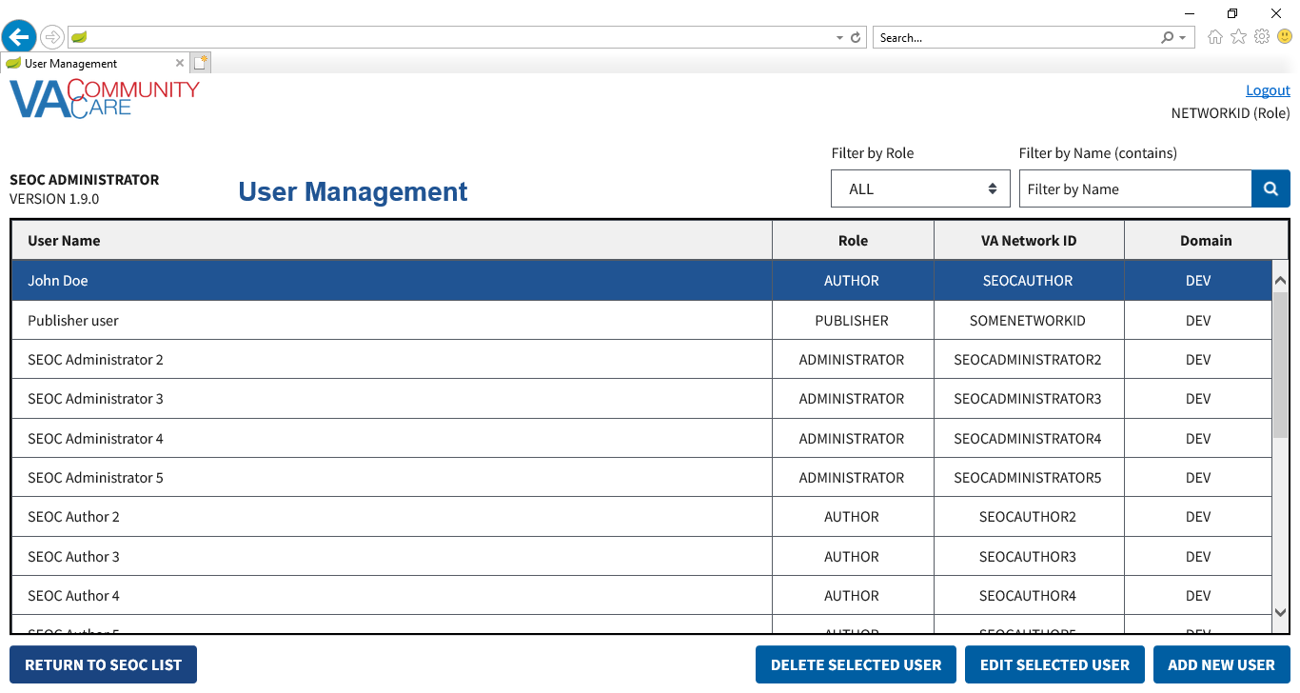

#### Filtering Users

To filter the list of users in SEOC by role or name, follow the steps listed below:

1. From the SEOC Admin home page, click **Manage Users**. The **User Management** window displays.
2. To filter the list of users by role, select **All**, **Viewer**, **Analyst**, **Author**, **Publisher**, or **Administrator** from the **Filter by Role** drop-down menu. The list refreshes to display the role selected.
3. To filter the list of users by name, enter the name in the **Filter by Name (contains)** field. The list refreshes to display the name or characters entered in the field.

Figure 7: Filtered List by Name Example

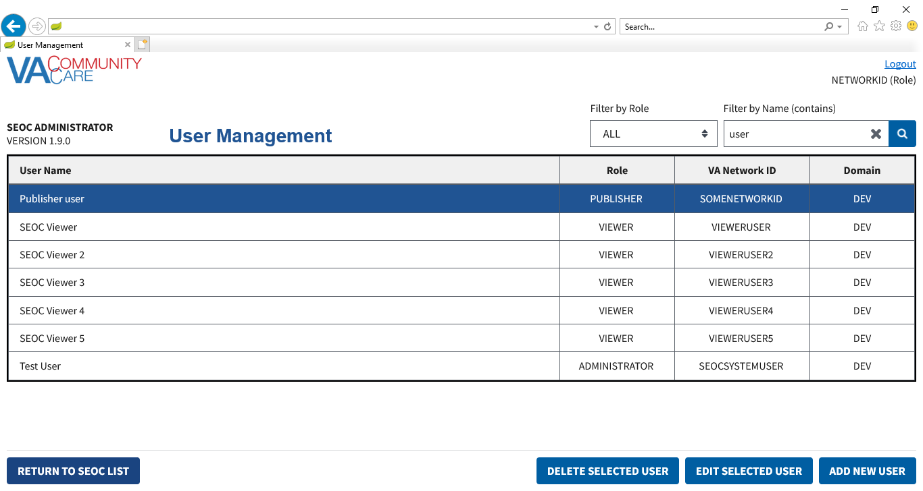

### Delete a Selected User

To delete a user from the User Management list, follow the steps listed below:

1. From the SEOC Admin home page, click **Manage Users**. The **User Management** window displays.
2. From the list of users, select the user that you would like to delete.
3. Click **Delete Selected User**. A message displays confirming that you would like to delete the user.

Figure 8: Delete Selected User Confirmation

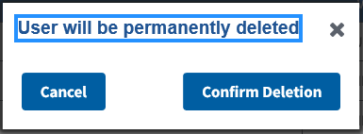

1. Click **Confirm Deletion**. The user is deleted from the list.

### Edit a Selected User

To edit a user in SEOC, follow the steps listed below:

1. From the SEOC Admin home page, click **Manage Users**. The **User Management** window displays.
2. From the list of users, select the user that you would like to edit.
3. Click **Edit Selected User**. The editable fields display.

Figure 9: Editable User Fields

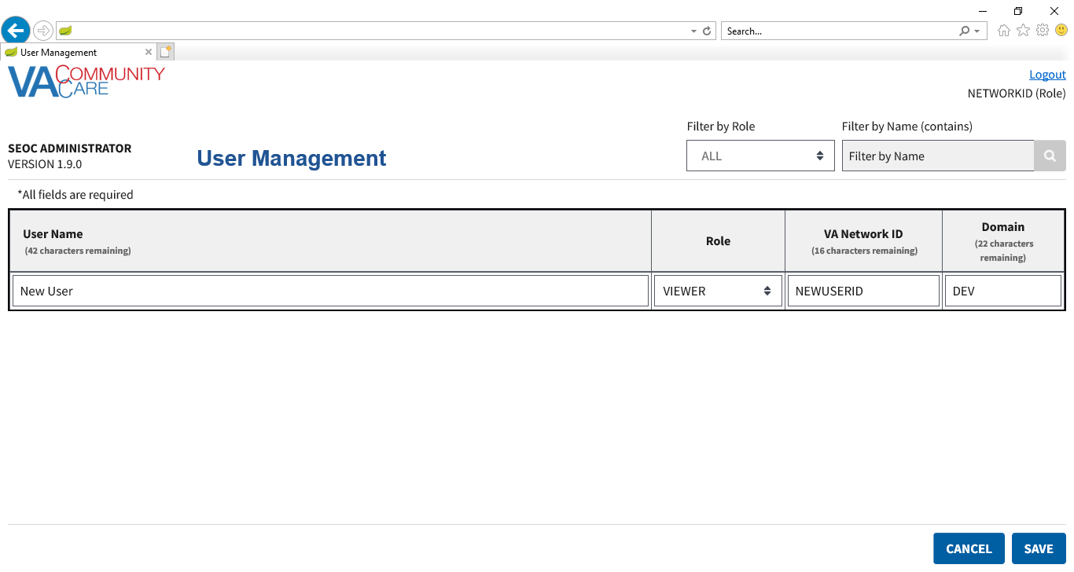

1. Edit the **User Name**, **Role**, **VA Network ID**, and **Domain** fields as needed.
2. Click **Save**. The updated user will display in the list of users.

### Add a New User

To delete a user from the User Management list, follow the steps listed below:

1. From the SEOC Admin home page, click **Manage Users**. The **User Management** window displays.
2. Click **Add New User**.

Figure 10: Add New User Fields

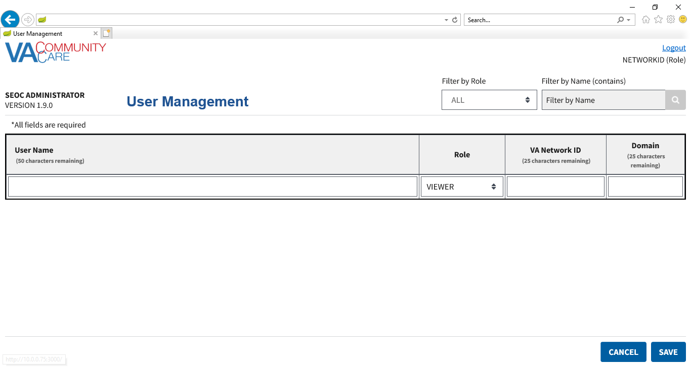

1. In the **User Name** field, enter the users name.
2. From the **Role** menu, select **Viewer**, **Analyst**, **Author**, **Publisher**, or **Administrator**.
3. In the **VA Network ID** field, enter the name of the VA network.
4. In the **Domain** field, enter the name of the domain.

## Export the SEOC Data to a JSON File

To export the **SEOC Data**, follow the steps listed below:

Figure 11: Export SEOC Data



1. As an **Analyst**, **Publisher**, or **Administrator** on the SEOC Admin home page, click **Export SEOC Data**. A dialog displays indicating the data is being downloaded.

Figure 12: Export SEOC Data Dialog

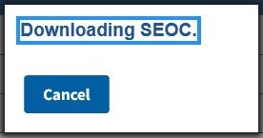

1. If needed, click **Cancel** on the dialog to cancel the data download.

## Export the SEOC PreCert Data to a JSON File

For all users who can **Export SEOC Data**, the **SEOC Admin UI** also allows them to export the data required for the **VA PreCert Website**.

To export the **SEOC PreCert Data**, follow the steps listed below:

Figure 13: Export SEOC Data



1. As an **Analyst**, **Publisher**, or **Administrator** on the SEOC Admin home page, click **Export PreCert Data**. A dialog will appear indicating the data is being downloaded.

Figure 14: Export SEOC PreCert Data Dialog

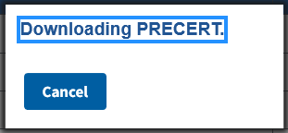

1. If needed, click **Cancel** on the dialog to cancel the data download.
2. Please refer to Appendix A for additional steps on converting the JSON file into an Excel file.

## Managing Billing Codes

1. When updating the Billing Codes, SEOC will go into maintenance mode. SEOC users will be unable to update the system until the Admin has completed managing the billing codes.
2. Maintenance mode can be turned off by any Admin.
3. When you click on Return to SEOC list from Billing Code Management, it will automatically turn maintenance mode off.

To manage the billing codes in SEOC, follow the steps listed below:

1. From the SEOC Admin home page, click **Manage Billing Codes**. The **Billing Code Management** window displays.

Figure 15: Billing Code Management

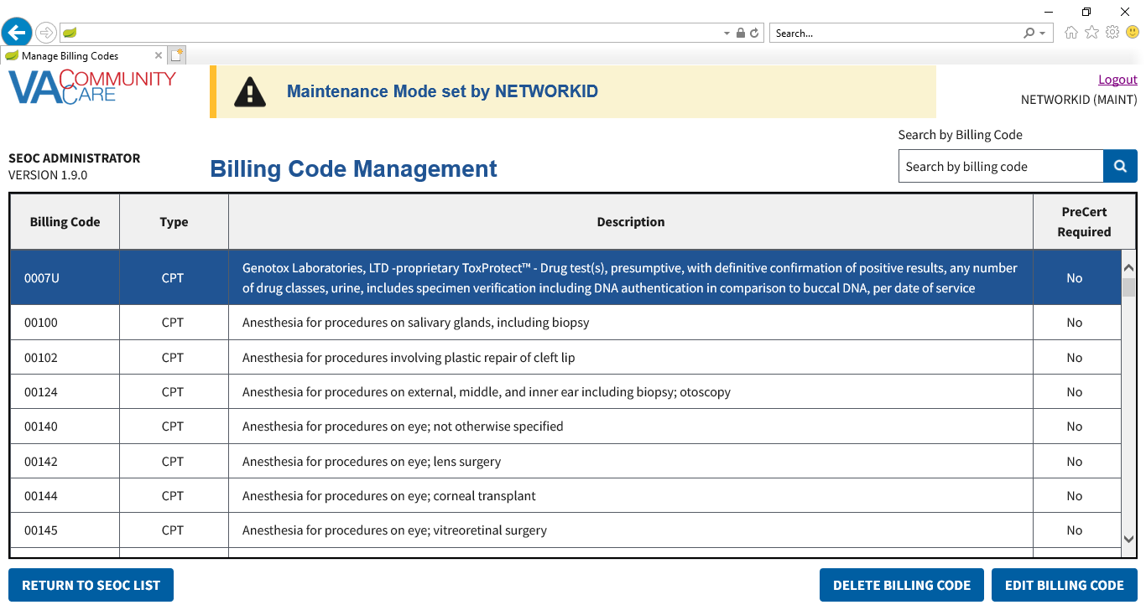

From the Billing Code Management window, you can delete billing codes and edit billing codes.

### Deleting Billing Codes

To delete billing codes in SEOC, follow the steps listed below:

1. From the SEOC Admin home page, click **Manage Billing Codes**. The **Billing Code Management** window displays.
2. From the list of billing codes, select the code that you would like to delete.
3. Click **Delete Billing Code**.

Figure 16: Confirm Delete Billing Code Message

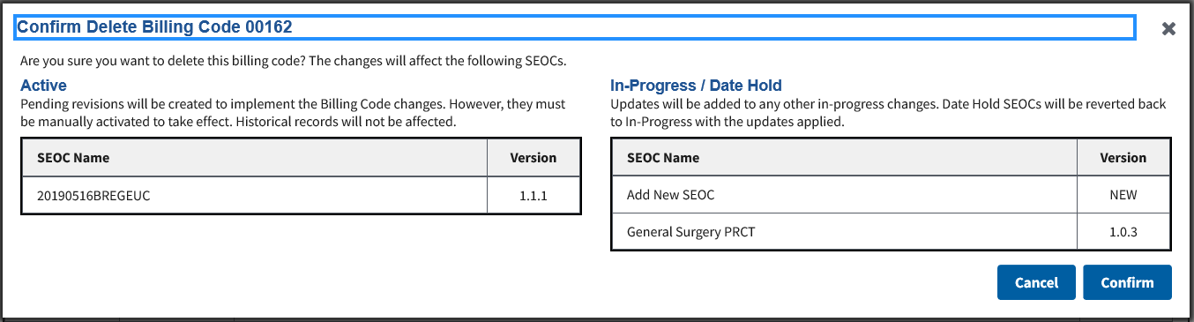

1. Verify that you want to delete the billing code listed, as the changes will affect the SEOCs listed in the Active and In-Progress tables.
2. Click **Confirm**. A message will display confirming that that the billing code was deleted and the billing code will no longer display in the list.

Figure 17: Billing Code Deletion Confirmation Message

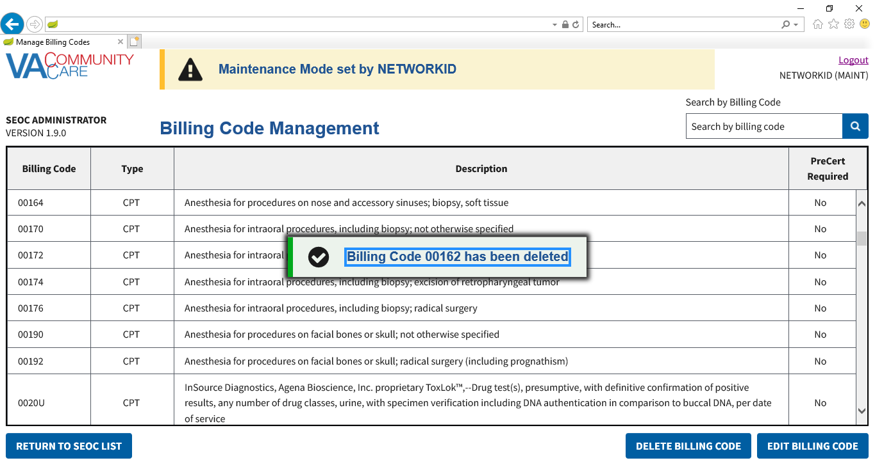

### Editing Billing Codes

To manage the billing codes in SEOC, follow the steps listed below:

1. From the SEOC Admin home page, click **Manage Billing Codes**.
2. From the list of billing codes, select the code that you would like to edit.
3. Click **Edit Billing Code**. The **Edit Billing Code** fields display.

Figure 18: Edit Billing Code

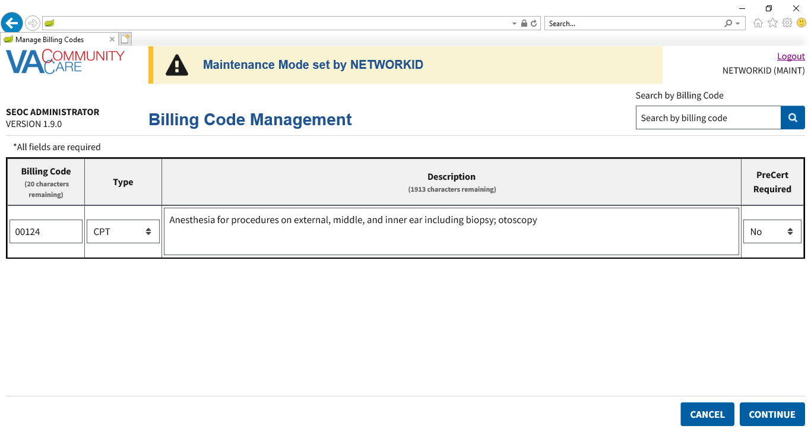

1. Update the **Billing Code** field as needed. The maximum number of characters for this field is 25.
2. From the **Type** field, select the correct option: **CPT**, **DRG**, **HCPCS**, **HIPPS**.
3. Update the **Description** field as needed. The maximum number of characters for this field is 2,000.
4. From the **PreCert Required** field, select the correct option: **NO** or **YES**.
5. Click **Continue**.

Figure 19: Edit Billing Code Confirmation Message

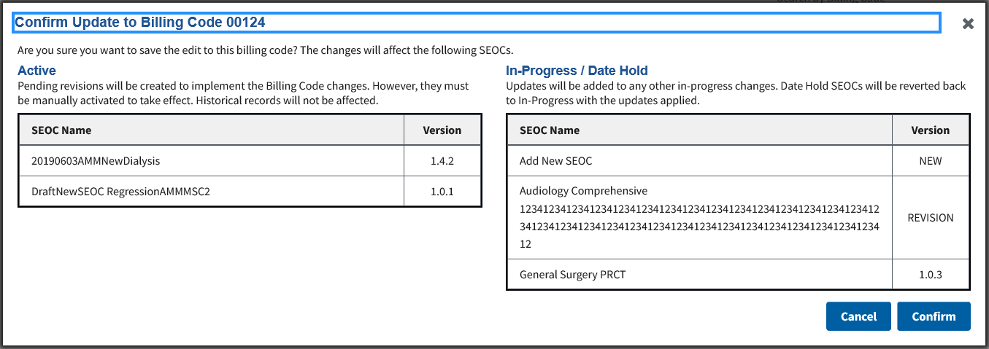

1. Verify that you want to delete the billing code listed, as the changes will affect the SEOCs listed in the Active and In-Progress tables.
2. Click **Confirm**. A confirmation message will display stating that the edits were made to the billing code.

## View SEOCs

### View a Selected SEOC

To view a SEOC from the SEOC list, follow the steps listed below:

1. From the SEOC Admin home page, select the SEOC you would like to view.
2. Click **View Selected SEOC**. The **View SEOC** page displays.

Figure 20: View SEOC

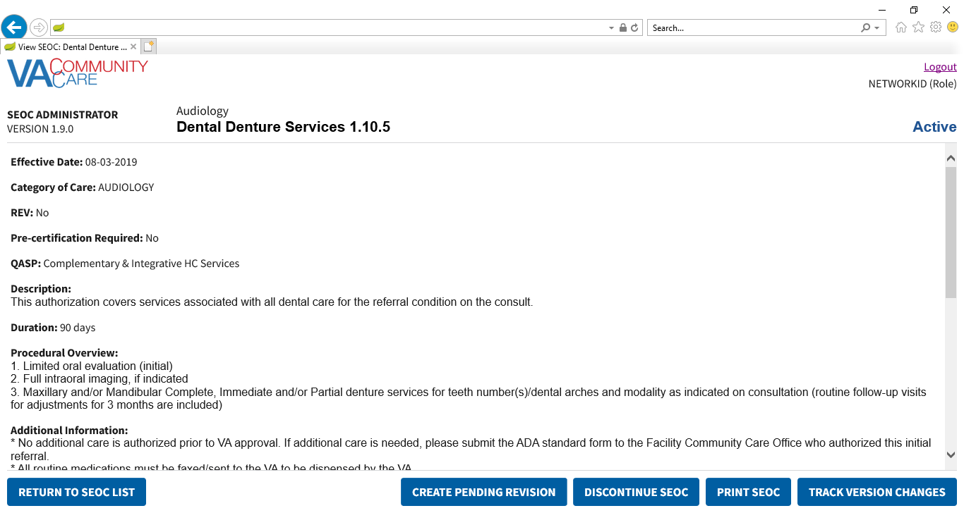

### Search for a SEOC by Name

To search for a SEOC, follow the steps listed below:

1. From the SEOC Admin home page, enter the name of the SEOC in the **Filter by Name (contains)** field.

Figure 21: SEOC Filter Field

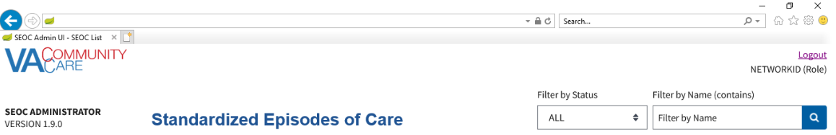

1. Click the **Search** button. The **Search SEOC Results** displays.

Figure 22: Search SEOC Results

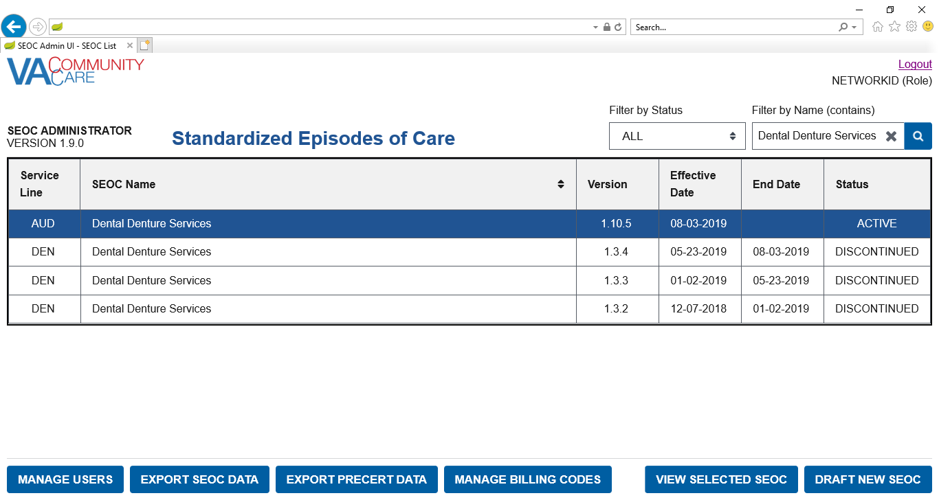

#### Sort SEOCs Alphabetically by Name

To sort the list of SEOCs alphabetically by name, follow the steps listed below:

1. From the SEOC Admin home page, select the **SEOC Name Column Heading**. This will sort the list of **SEOCs** in alphabetical order by name.

Figure 23: SEOC Name Column Heading

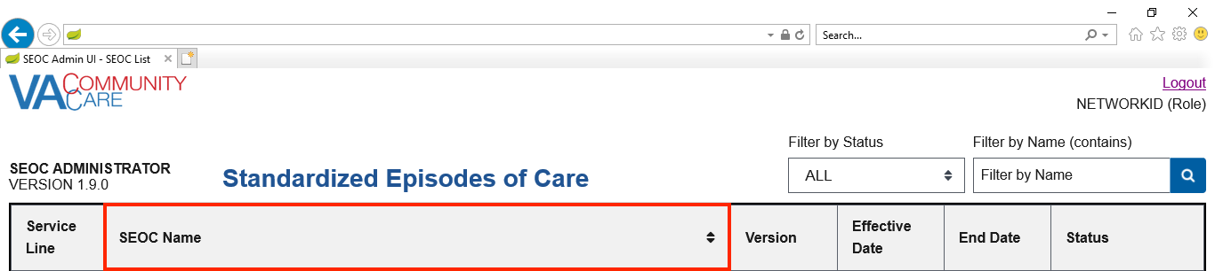

Figure 24: SEOC List Sorted in Alphabetical Order by Name

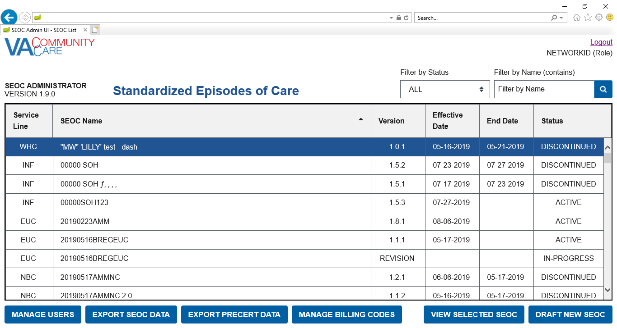

1. To sort the list of **SEOCs** in reverse alphabetical order, select the **SEOC Name Column Heading** again.

Figure 25: SEOC List Sorted in Reverse Alphabetical Order by Name

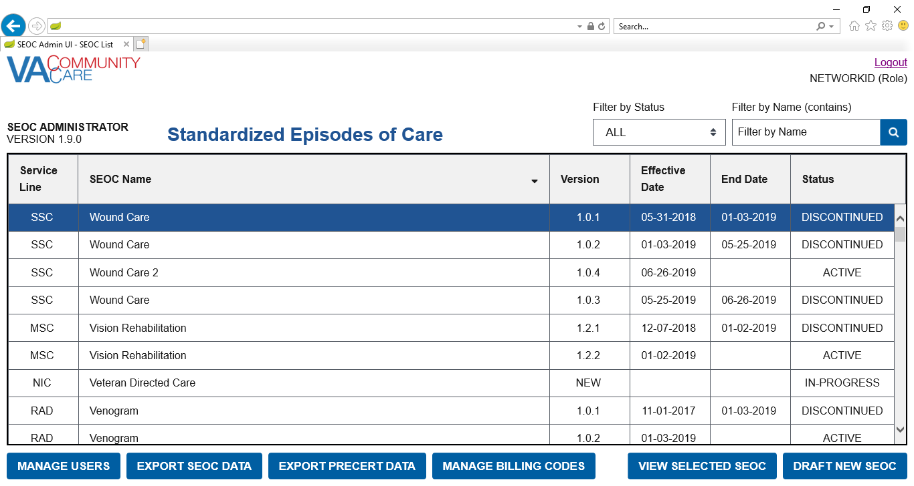

1. To return to the default sort order, either refresh the page or click the logo in the upper-right-hand corner of the page.

### Filter SEOCs by Status

To filter the list of SEOCs by status, follow the steps listed below:

1. From the SEOC Admin home page, select **Filter By Status** menu.

Figure 26: Filter by Status Menu Options

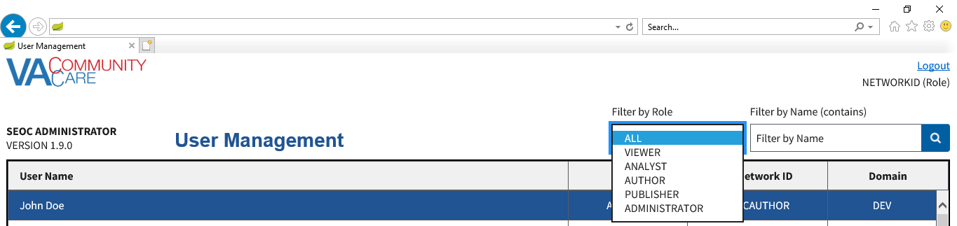

1. From the list of options select to filter by: **All**, **Active**, **Date Hold**, **Discontinued**, or **In-Progress**. The SEOC list refreshes to display the status filtered by.

### Discontinue a SEOC

To discontinue a selected Active SEOC, follow the steps listed below:

1. From the SEOC Admin home page, select the SEOC you would like to discontinue.
2. Click **View Selected SEOC**, the **View SEOC** page displays.
3. Click **Discontinue SEOC**. The discontinue SEOC confirmation dialog box displays.

Figure 27: Discontinue SEOC Confirmation

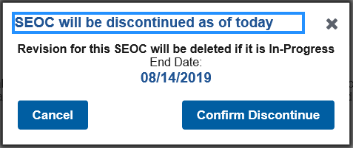

1. Click **Confirm Discontinue**. The **View SEOC** page displays with the updated status of the SEOC.

Figure 28: Discontinued Status

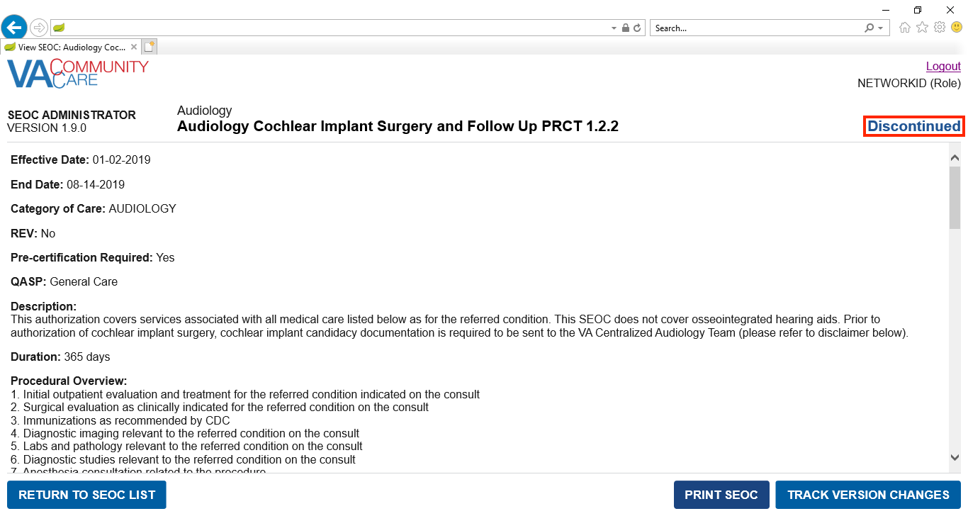

### Print a SEOC

To print a SEOC, follow the steps listed below:

1. From the SEOC Admin home page, select the SEOC you would like to print.
2. Click **View Selected SEOC**, the **View SEOC** page displays.
3. Click **Print SEOC**. The printed SEOC will display in another window. Print or save using local browser capabilities.

Figure 29: Printed SEOC Window

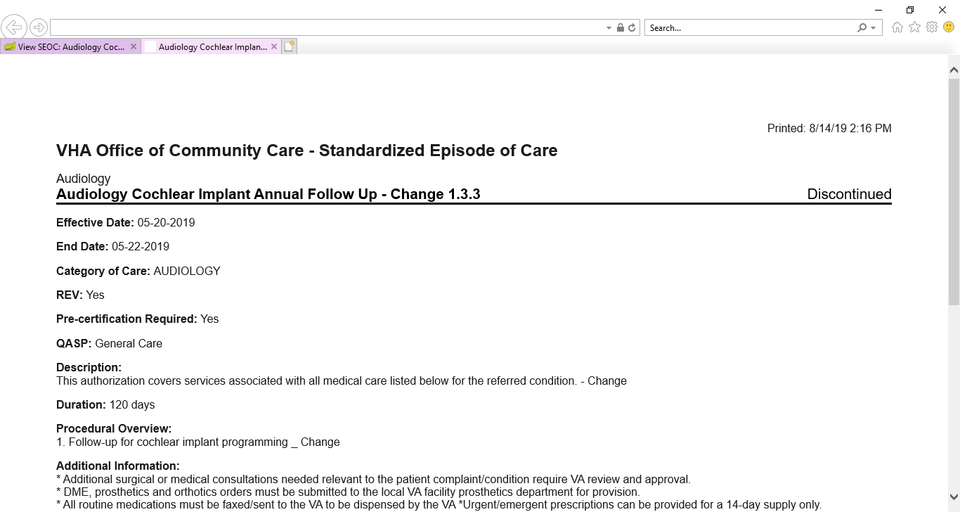

### Invalid Characters

The following business rules for valid characters are enforced in the SEOC Admin UI:

* For the **Description**, **Procedural Overview**, and **Additional Information** fields in a **SEOC**, and the **Description** field in a **Payable Service**, the following characters are accepted:
* Line Feed (ASCII 10)
* Carriage Return (ASCII 13)
* The printable ASCII characters (ASCII 32 – 126) except the DELETE character (ASCII 127)
* For the **SEOC Name**, the above characters are accepted except:
* & - Ampersand (ASCII 38)
* / - Slash (ASCII 47)
* : - Colon (ASCII 58)
* \ - Backslash (ASCII 92)
* ^ - Caret (ASCII 94)
* | - Vertical Bar (ASCII 124)
* ~ - Tilde (ASCII 126)
* For a **Billing Code** value, the following characters are accepted:
* Letters
* Numbers
* - Hyphen (ASCII 45)
* . - Period (ASCII 46)

The user will not be able to activate a SEOC unless all of these rules have been followed. In the case of the **SEOC Name**, the user will be unable to navigate past the **SEOC Name** and **Service Line** page of the **Create / Edit SEOC Workflow** if the **SEOC Name** has invalid characters. For **Billing Codes**, the user will be unable to save the **Billing Code** if the **Billing Code** value has invalid characters.

The **Show Invalid Characters** feature allows the user to highlight invalid characters on any SEOC, regardless of status.

#### Show Invalid Characters

To show invalid characters on a SEOC, follow the steps listed below:

1. From the SEOC Admin home page, select a **SEOC** with invalid characters.
2. Click **View Selected SEOC**, the **View SEOC** page will display.
3. Click **Show Invalid Characters**. The **Show Invalid Characters** page will display.

Figure 30: Show Invalid Characters Button



Figure 31: Show Invalid Characters

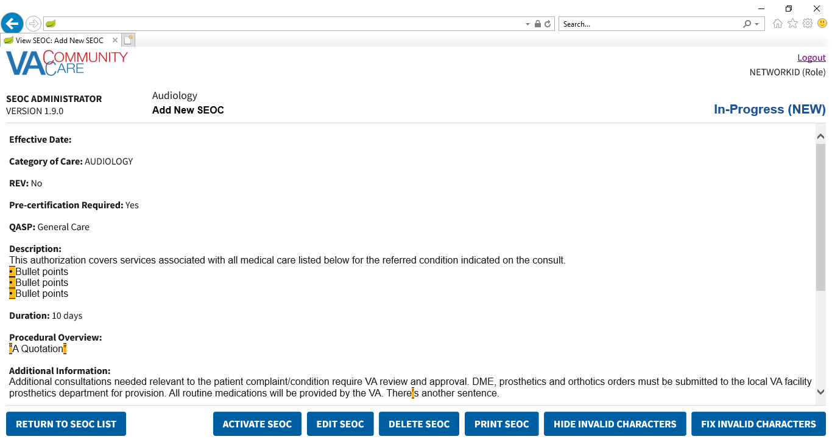

1. To print the **SEOC** with invalid characters shown, click **Print SEOC**. The **Print SEOC** page will display with invalid characters shown.

Figure 32: Print SEOC from Show Invalid Characters Page

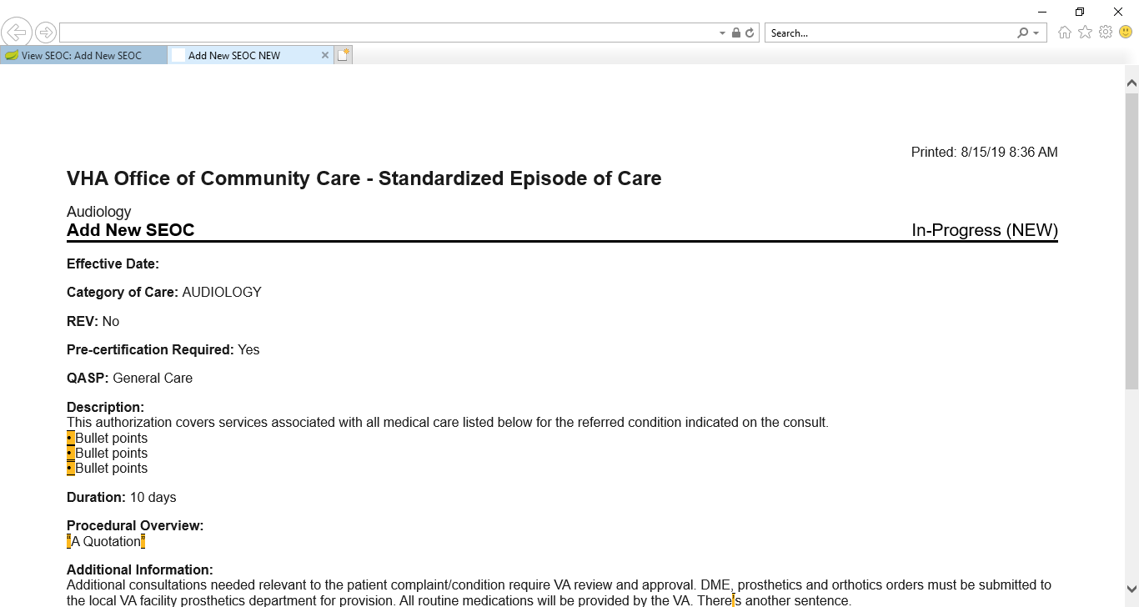

Figure 33: Print SEOC from Show Invalid Characters (Bottom of the Page)

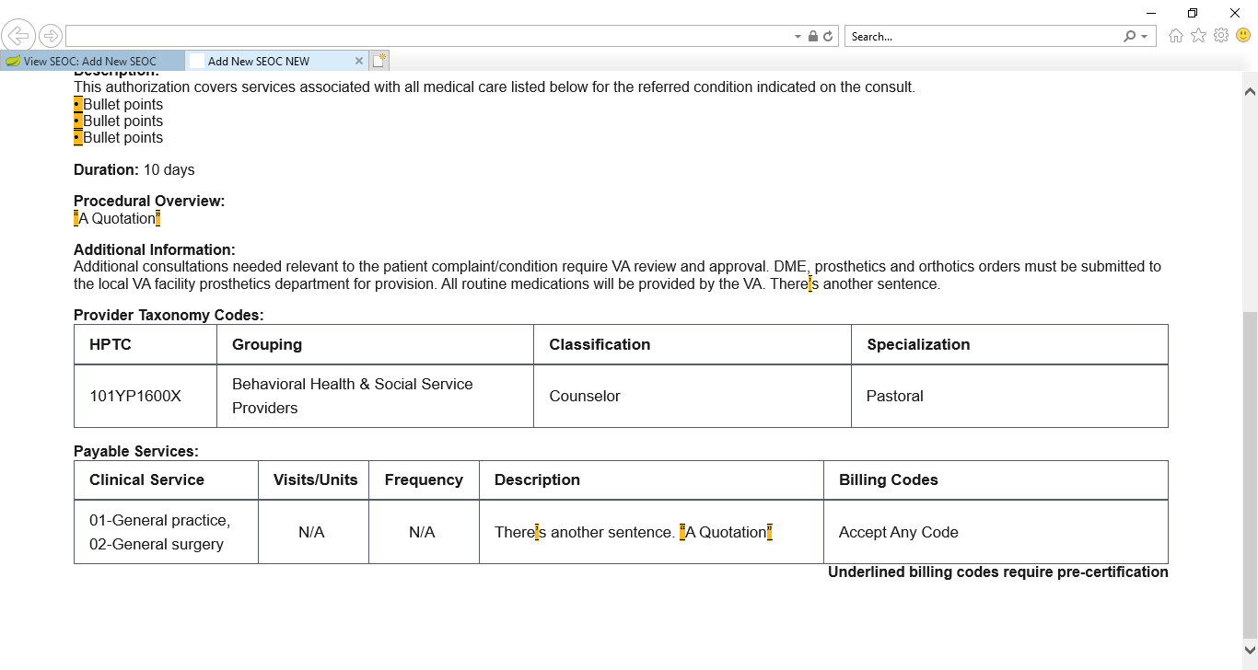

1. To return to the **View SEOC** page from the **Show Invalid Characters** page, click the **Hide Invalid Characters** button.

Figure 34: Hide Invalid Characters Button



1. The **Show Invalid Characters** button is only available if the SEOC has invalid characters.

#### Fix Invalid Characters

Invalid characters in a **SEOC** can either be fixed manually through the **Edit SEOC** workflow, or automatically with the **Fix Invalid Characters** feature. Invalid characters are fixed as follows:

* |, ^, ~, \, /, and & in the SEOC Name will be replaced with spaces
* ‘ or ’ will be replaced with '
* “ or ” will be replaced with "
* • or · will be replaced with *
* – or – will be replaced with –
* All other characters will be replaced with a space

To automatically **Fix Invalid Characters**, follow the steps listed below:

1. From the SEOC Admin home page, select a **SEOC** with invalid characters.
2. Click **View Selected SEOC**, the **View SEOC** page will display.
3. Click Show Invalid Characters. The Show Invalid Characters page will display.
4. Click **Fix Invalid Characters**. The **Fix Invalid Characters** confirmation dialog will display.

Figure 35: Fix Invalid Characters Button



Figure 36: Fix Invalid Characters Confirmation

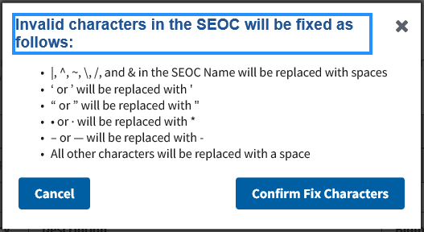

1. Click **Confirm Fix Characters**. A confirmation message will display.

Figure 37: Invalid Characters Fixed Message

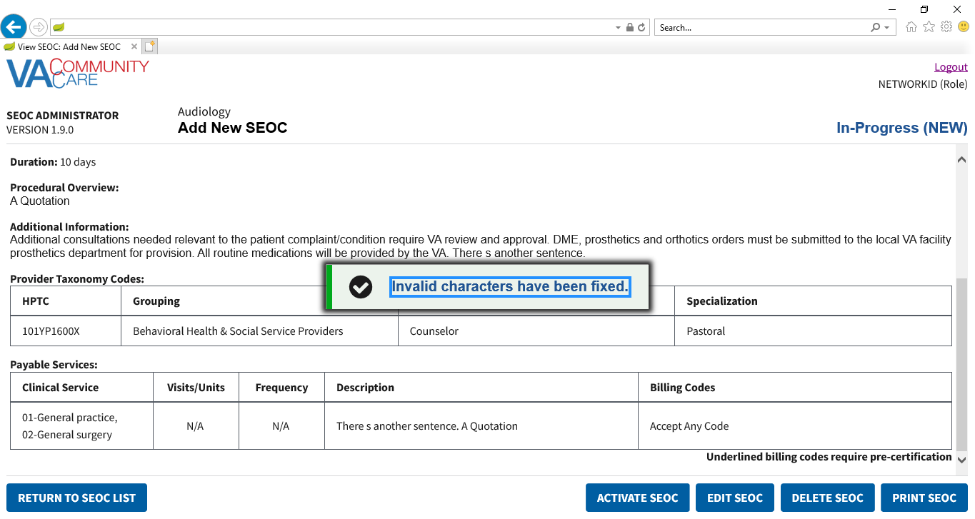

1. This feature is only available for **In-Progress SEOCs**. For **Active SEOCs** with invalid characters, create a **Pending Revision**, then fix the invalid characters.

### Track Version Changes

To track the version changes of a SEOC, follow the steps listed below:

1. From the SEOC Admin home page, select a **SEOC** with a previous version.
2. Click **View Selected SEOC**, the **View SEOC** page displays.
3. Click the **Track Version Changes** button when it becomes active. The **Track Version Changes** page will display.

Figure 38: Track Version Changes Page

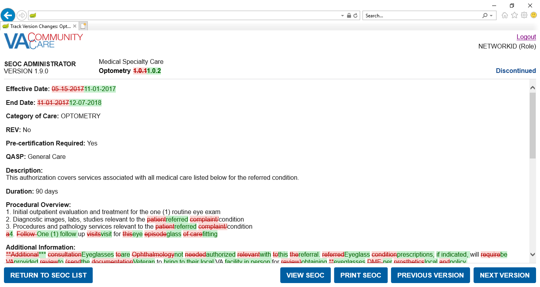

Figure 39: Track Version Changes: Additional Information and Provider Taxonomy Codes

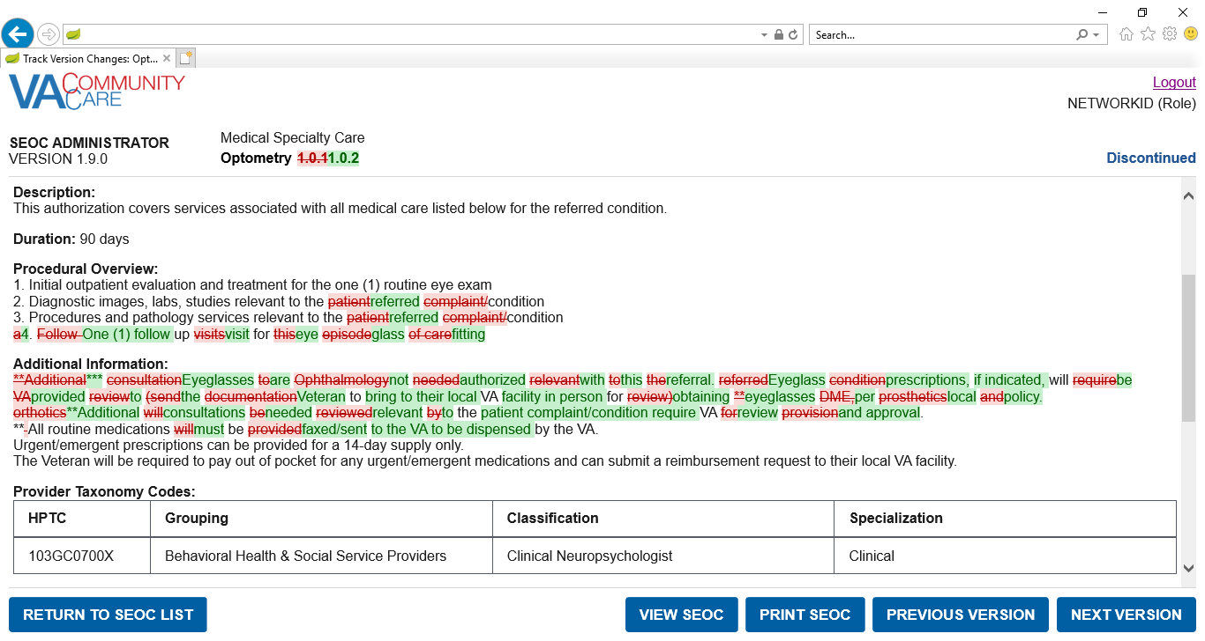

Figure 40: Track Version Changes: Payable Services

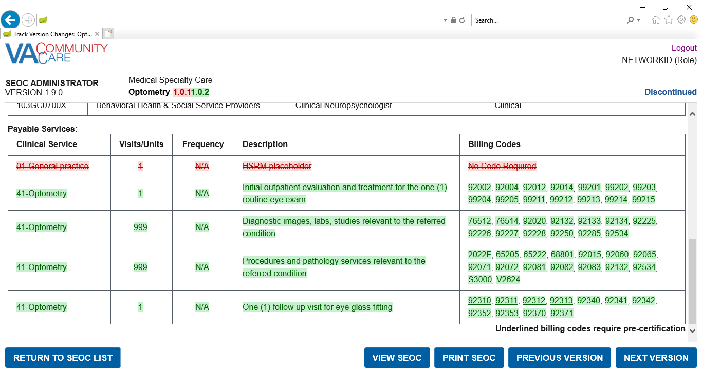

1. Click the **Previous Version** button. The changes for the previous version will be shown. If the previous version is the first version of this **SEOC**, no changes will be displayed.
2. Click the **Next Version** button. The changes for the next version will be shown.
3. Click the **Print SEOC** button. The **Print SEOC** page will display with the current changes.

Figure 41: Print SEOC from Track Version Changes Page

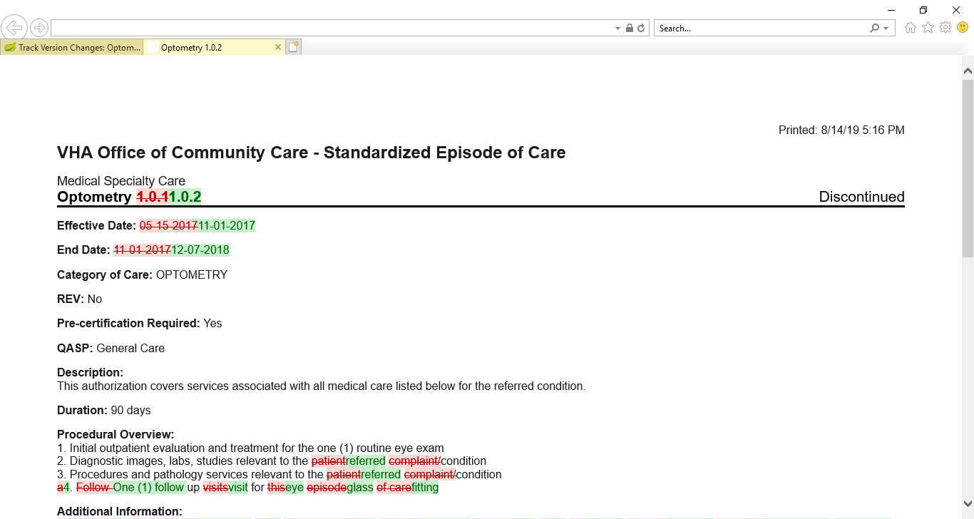

Figure 42: Print SEOC from Track Version Changes: Additional Information and Provider Taxonomy Codes

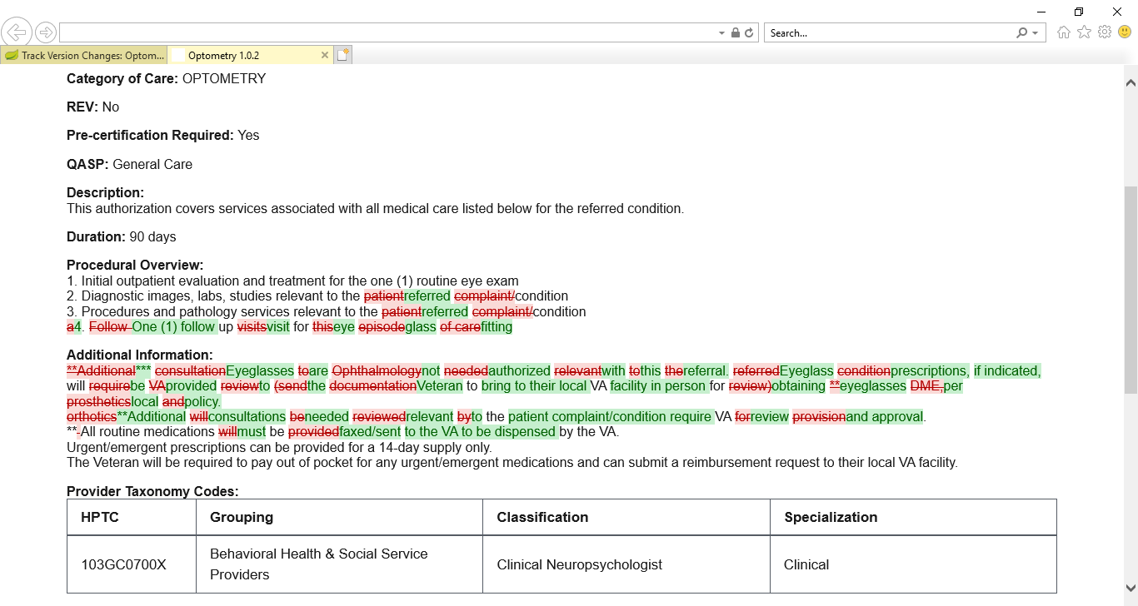

Figure 43: Print SEOC from Track Version Changes: Payable Services

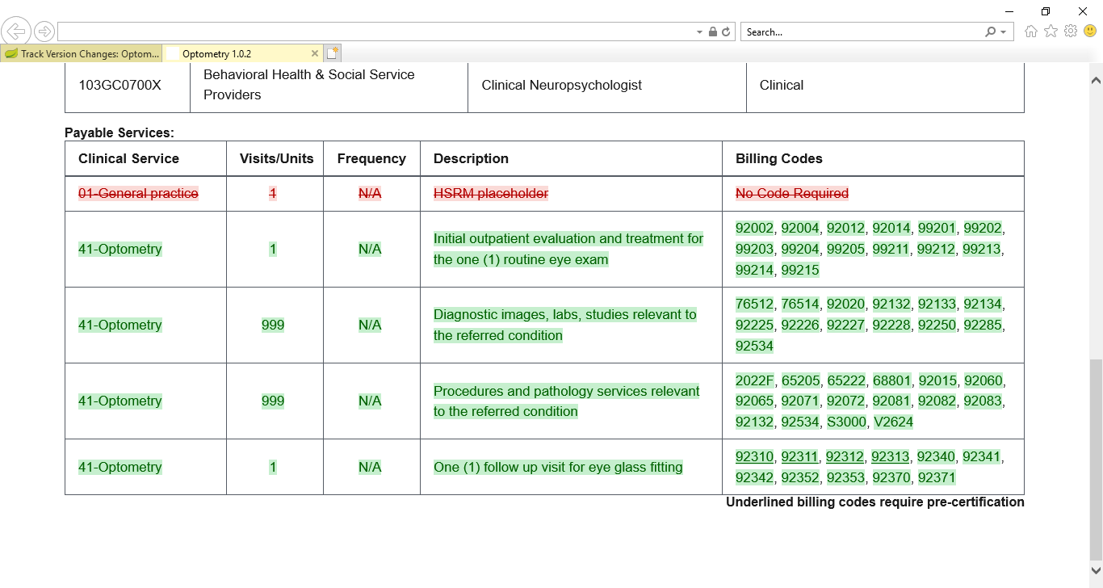

1. By default, IE11 will not print the red and green background colors. In order to print the red and green background colors, check the **Print Background Colors and Images** box in the **Page Setup** dialog from the **Print** menu.

## Draft a New SEOC

To draft a new SEOC, follow the steps listed below:

1. From the SEOC Admin home page, click **Draft New SEOC**. The **Draft SEOC: Name** window displays.

Figure 44: Draft SEOC: Name

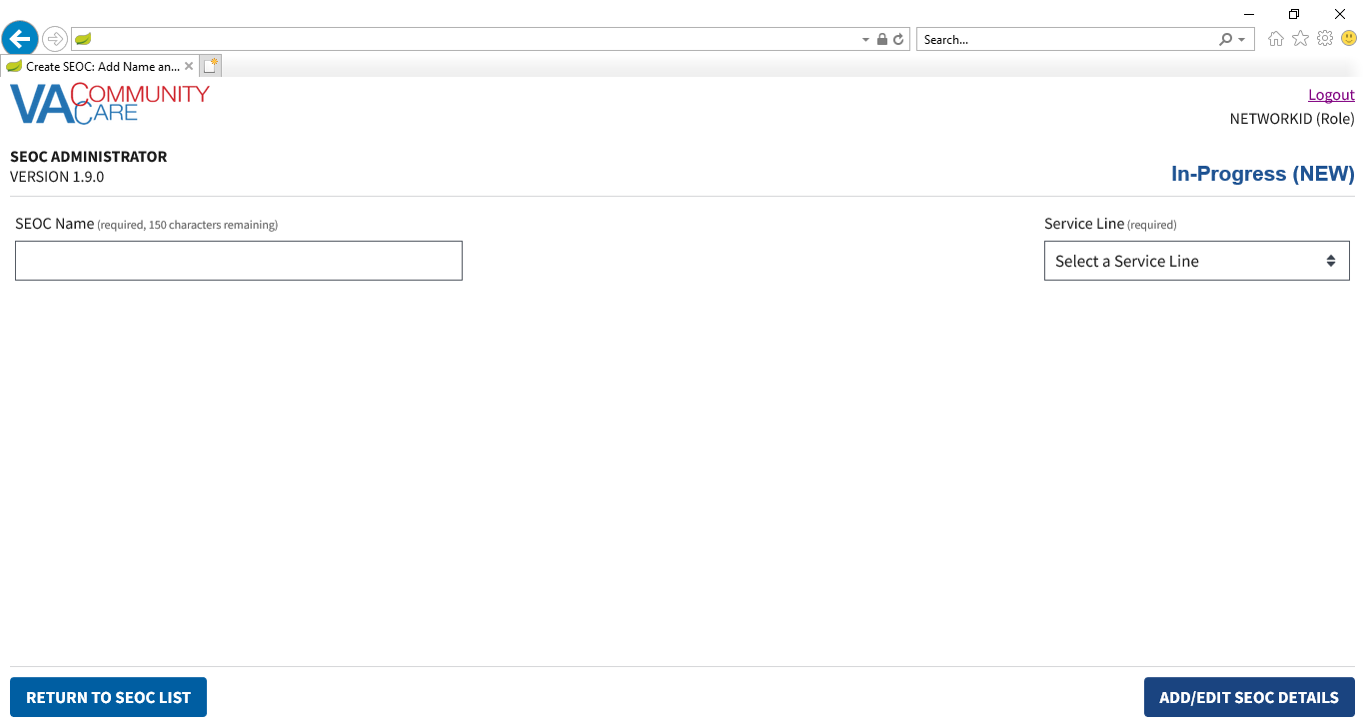

1. In the **SEOC Name** field, enter the name for the new SEOC (required field).
2. From the **Service Line** menu, select a service line (required field).
3. Click **Add/Edit SEOC Details**. The **Draft SEOC: Details** window displays.

Figure 45: Draft SEOC Details

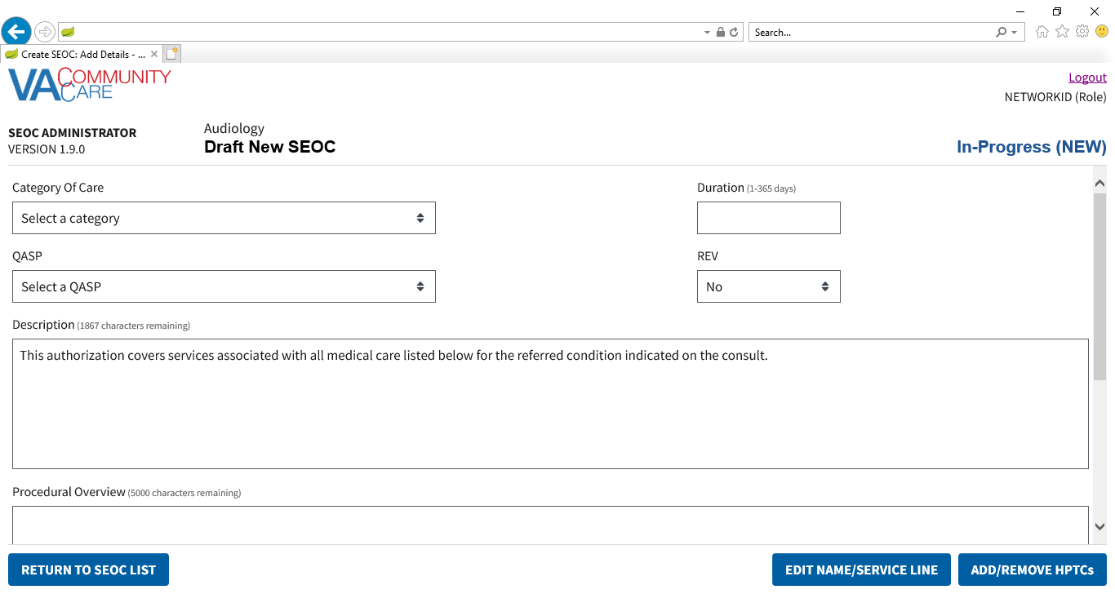

1. From the **Category of Care** drop-down menu, select the category.
2. In the **Duration (days)** field, enter the duration.
3. From the **PAL** drop-down menu, select **Yes** or **No**.
4. From the **QASP** drop-down menu, select a QASP:

* **Complimentary & Integrative Health Care**
* **General Care**
* **General Dental Care**
* **Primary Care**
* **Specialty Dental Care**

1. From the **PAL** drop-down menu, select **No** or **Yes**.
2. In the **Description** field, enter a description for the procedure. The maximum amount of characters for this field is 500.
3. In the **Procedural Overview** field, enter an overview on the procedure. The maximum amount of characters for this field is 5000.
4. In the **Additional Information** field, enter additional information regarding the procedure. The maximum amount of characters for this field is 2000.
5. Click **Add/Remove HPTCs**. The **Add/Remove HPTCs** window displays.

Figure 46: Add/Remove HPTCs

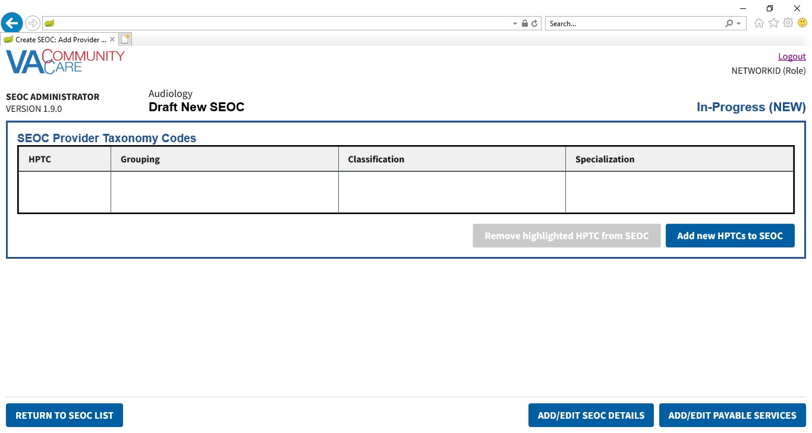

1. Click **Add new HPTCs to SEOC**. A list of provider taxonomy codes displays.

Figure 47: Provider Taxonomy Code List

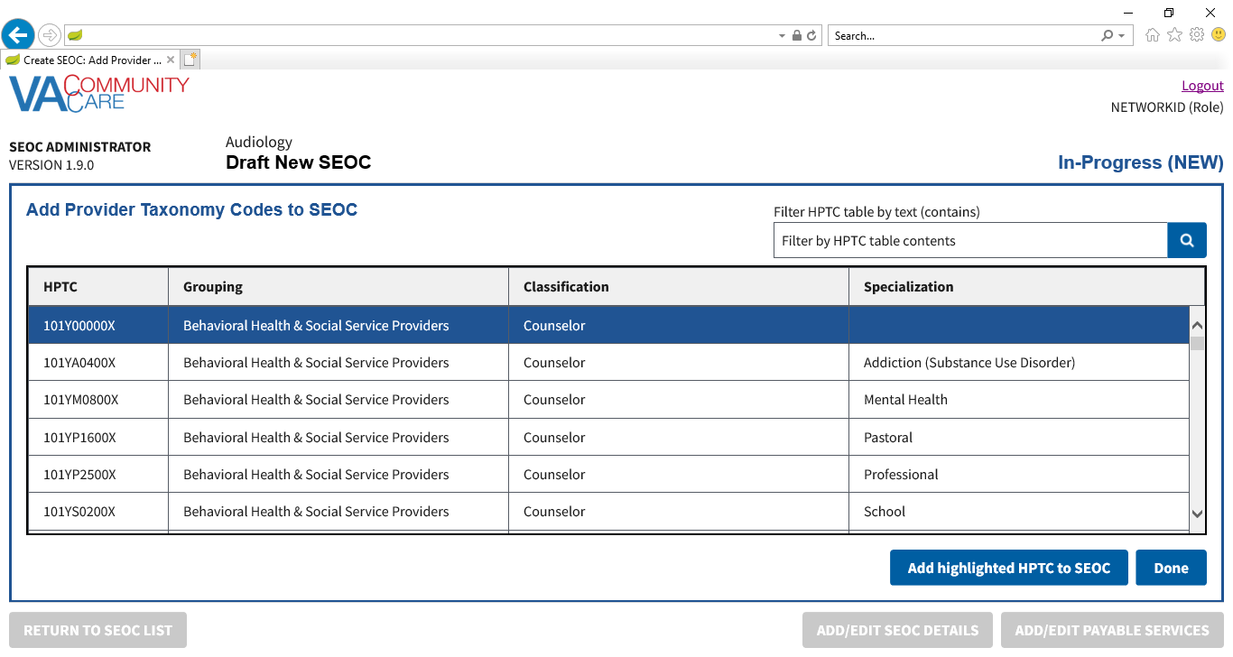

1. From the list of provider taxonomy codes select the HPTC to add to the SEOC. Another option is to use the **Filter HPTC table by text (contains)** field to filter the list of HPTCs and select the HPTCs from the filtered list.
2. You must add at least one HPTC to activate the SEOC.
3. Click **Add highlighted HPTC to SEOC**. A confirmation message displays telling you the HPTC was added.

Figure 48: Draft SEOC: Provider Taxonomy Code Added Message

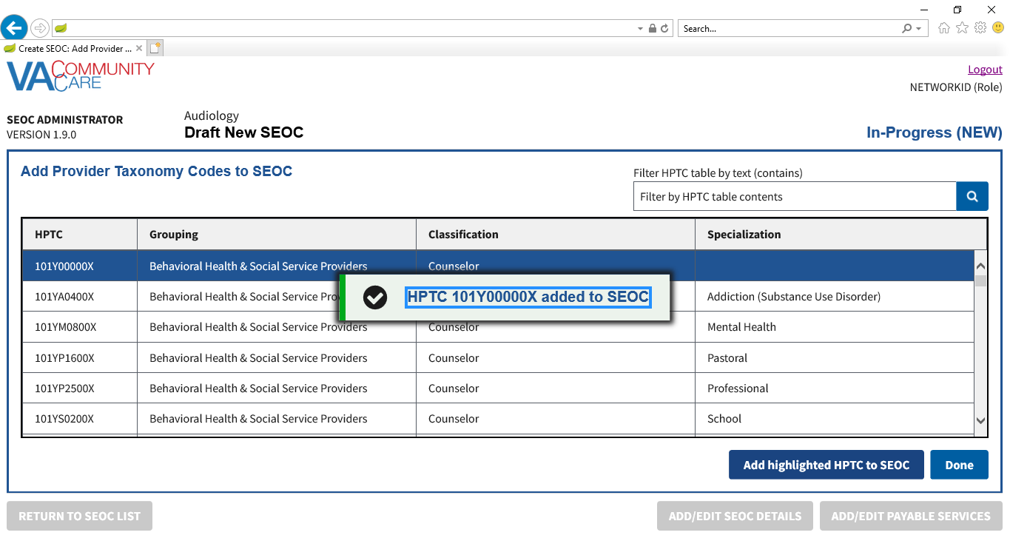

1. Repeat steps 14-16 to add additional **HPTCs** to the **SEOC**
2. When you are finished adding provider codes, click **Done**. The **Draft SEOC:** **SEOC Provider Taxonomy Codes** page will display. The table displays the provider codes you added on the previous page.

Figure 49: Draft SEOC: Added Provider Taxonomy Codes

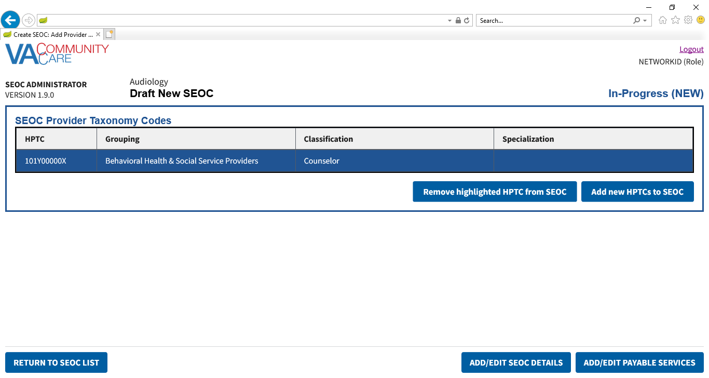

1. If needed, you can select an **HPTC** row and click **Remove highlighted HPTC from SEOC** to remove an **HTPC**. The **Confirm Remove HPTC** dialog will display. Click **Confirm** to remove the **HPTC** from the **SEOC**.

Figure 50: Draft SEOC: Confirm Remove HPTC

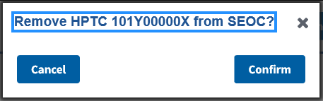

1. Click **Add/Edit Payable Services**. The **Draft SEOC: Payable Services** window displays.

Figure 51: Draft SEOC: Payable Services

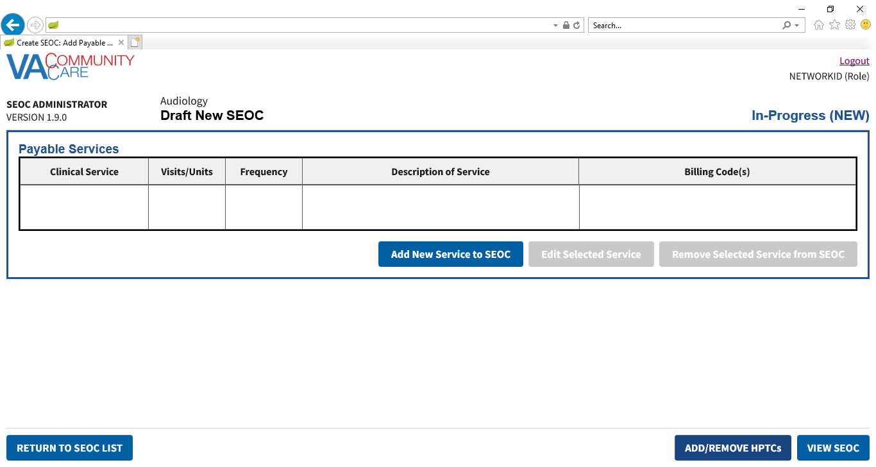

1. Click **Add New Service to SEOC**. The **Draft SEOC: Add Payable Service** section displays at the bottom of the page.

Figure 52: Draft SEOC: Add Payable Service

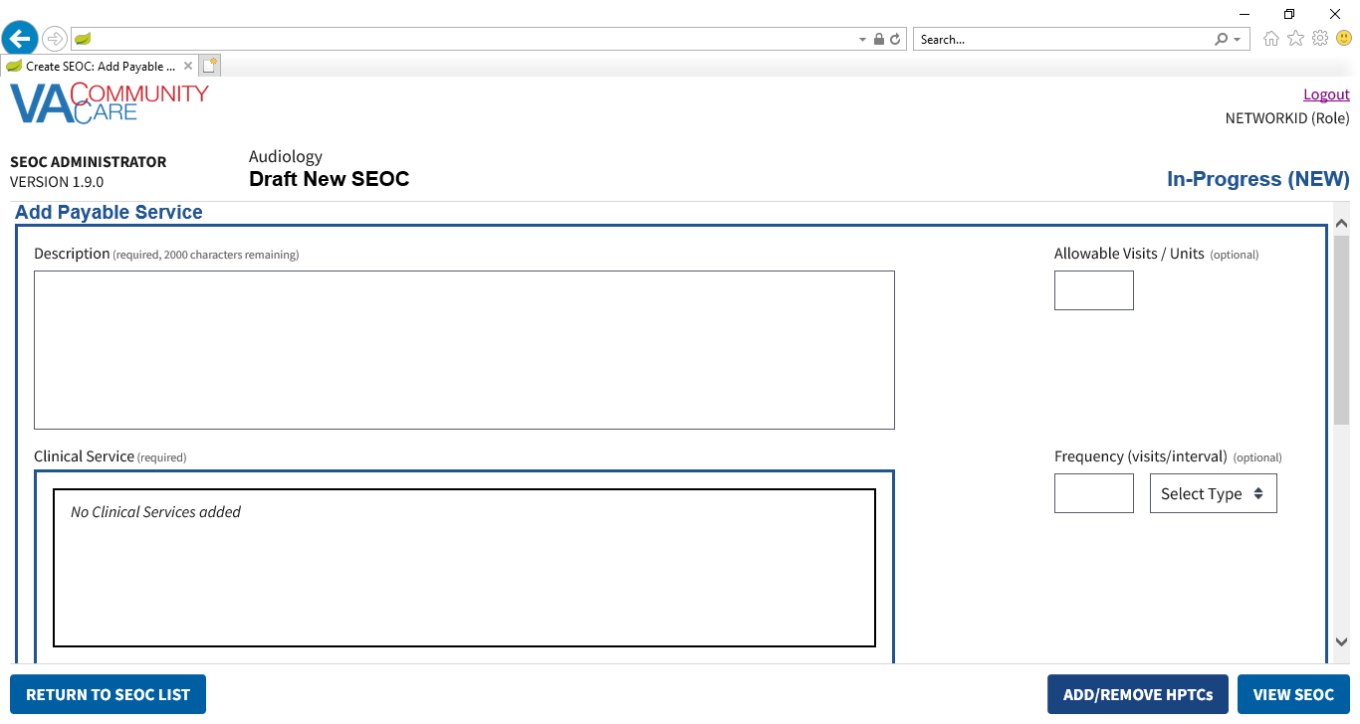

1. In the **Description** field, which is required, enter a description for the payable service.
2. The maximum number of characters for the **Description** field is 2000.
3. In the **Allowable Visits/Units** field, enter the number of allowed visits.
4. The maximum value for the **Allowable Visits/Units** field is 999.
5. Under the **Clinical Service** section, which are required, click **Add Clinical Service**. The **Draft SEOC: Add Clinical Service** dialog box displays.

Figure 53: Draft SEOC: Add Clinical Service

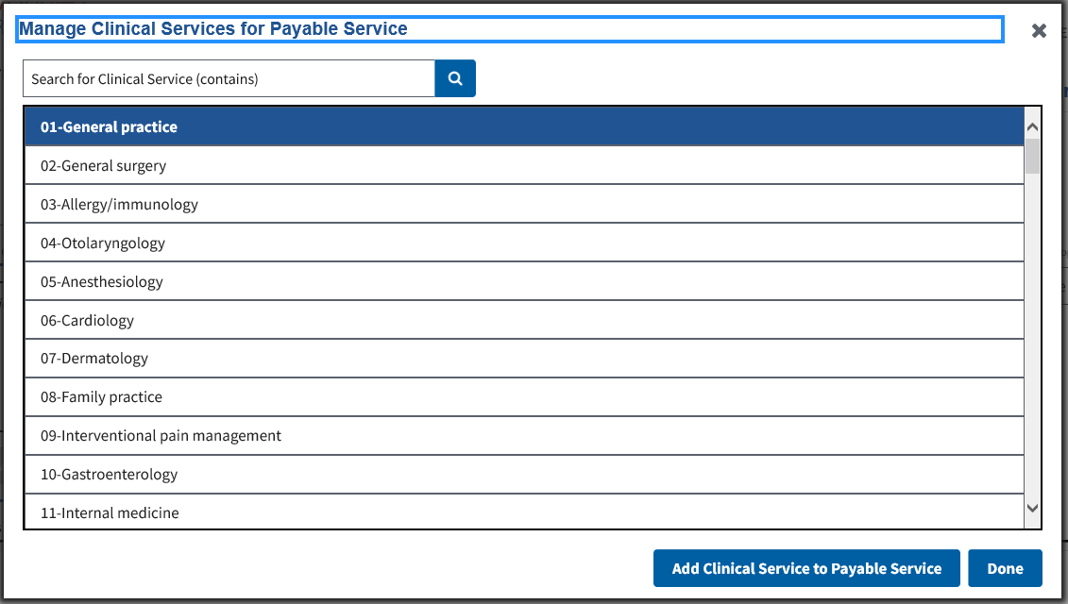

1. Enter text in the **Search for Clinical Service** field. Press **Enter** or click the **Search** button. The table displays all rows with the text you entered.
2. Select the desired **Clinical Service**.
3. Click **Add Clinical Service to Payable Service**. A confirmation message displays telling you the clinical service was added.

Figure 54: Draft SEOC: Clinical Service Added Message

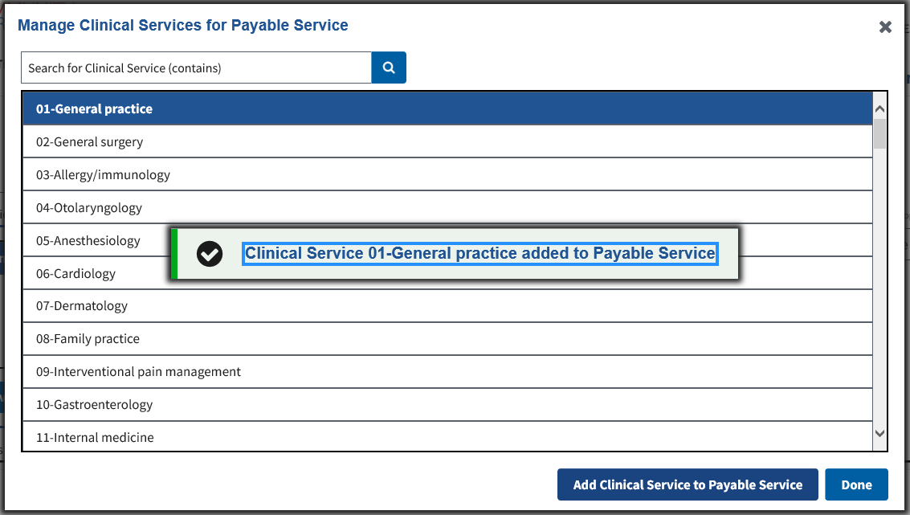

1. Repeat steps 24-26 to add additional **Clinical Services** to the **Payable Service**.
2. Click **Done**. The clinical service displays in the **Clinical Service** field.

Figure 55: Draft SEOC: New Clinical Services Added to the Payable Service

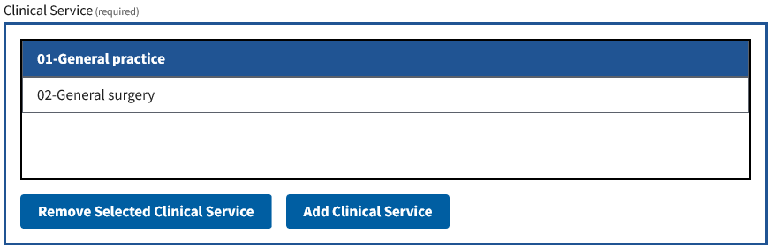

1. If needed, select a **Clinical Service** row and click **Remove Selected Clinical Service** to remove a **Clinical Service**.
2. In the **Frequency (visits/interval)** field, which is optional, enter the number of visits and select if it is per week, month, or year.
3. The maximum value for the **Frequency (visits/inverval)** field is 999.
4. If either the **Frequency** **Visits** or the **Frequency Interval** field is populated without the other, an error will be displayed if you click **Done**.
5. If no billing codes are required, select **No Code Required**.
6. If this service can accept any billing code, select **Accept Any Code**.
7. If this service requires billing codes, click **Add New Billing Code to Service**. The **Draft SEOC: Add Billing Code** dialog box displays.

Figure 56: Draft SEOC: Add Billing Code

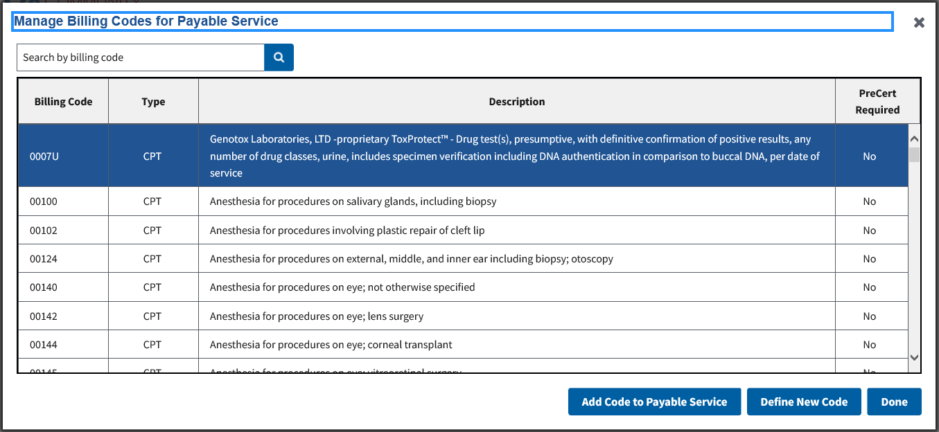

1. Enter text in the **Search by billing code** field. Press Enter or click the **Search** button. The table will display all rows where the **Billing Code** column starts with the text you entered.
2. Select the desired **Billing Code**.
3. Click **Add Code to Payable Service**. A confirmation message displays.

Figure 57: Draft SEOC: Billing Code Added Message

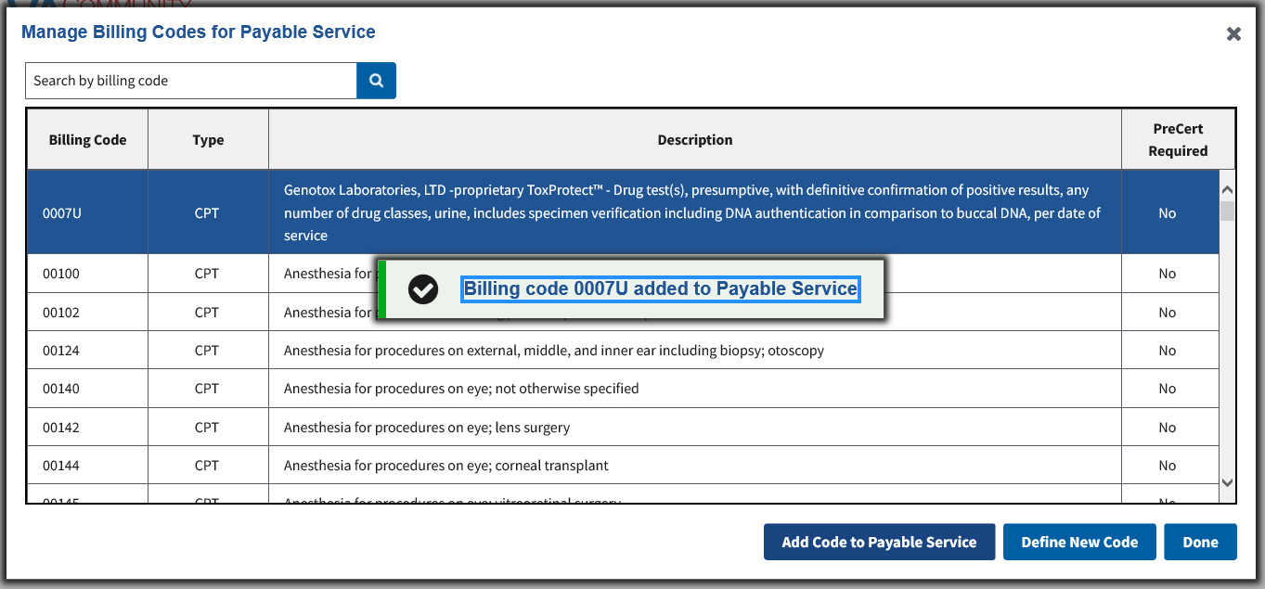

1. Repeat steps 35-37 to add additional **Billing Codes** to the **Payable Service**.
2. To define a new **Billing Code**, click **Define New Code**. The **Define New Code** form displays.

Figure 58: Define New Code

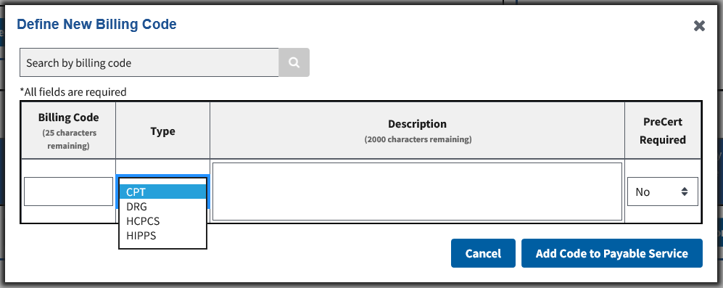

1. If you had entered a billing code in the **Search by Billing Code** **Field** before clicking **Define New Code**, the **Billing Code Field** will be pre-populated with the value from the **Search by Billing Code Field.**
2. If the pre-populated value for the **Billing Code Field** starts with a letter, the **Type** menu will default to **DRG**. Otherwise, it will default to **CPT**.
3. In the **Billing Code** field, which is required, enter the billing code.
4. The maximum number of characters for the **Billing Code** field is 25.
5. From the **Type** menu, select the type of billing code (required field).
6. In the **Description** field, which is required, enter the billing code description.
7. The maximum number of characters for the **Description** field is 2000.
8. From the **PreCert Required** menu, select whether the billing code requires pre-certification (required field).
9. Click **Add Code to Payable Service**. The new code will be added to the current payable service. A confirmation message will display. It will also be available in the list of billing codes in the **Add Billing Code** dialog box.

Figure 59: Draft SEOC: New Billing Code Added Message

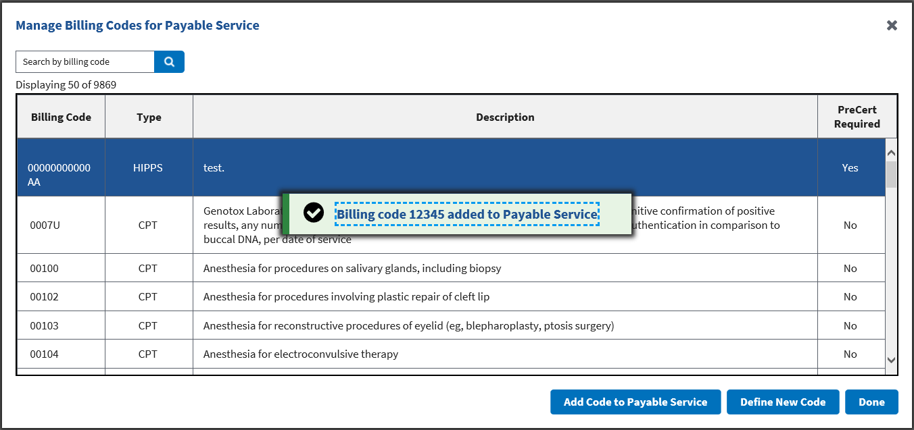

1. If any of the fields are not populated, or if there are any characters in the **Billing Code** field that are not letters, numbers, a hyphen, or a period, an error message will appear when you click **Add Code to Payable Service**.

Figure 60: Duplicate Billing Code Message

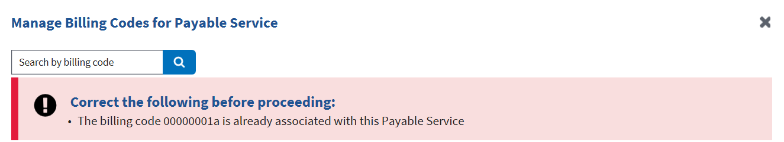

1. Click **Done**. The **Draft SEOC: Add Payable Service** section displays.

Figure 61: Draft SEOC: Billing Codes Added to the Payable Service

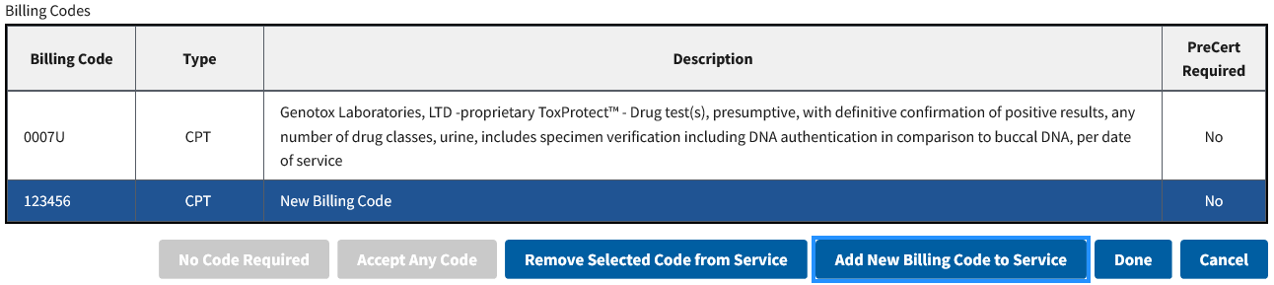

1. If needed, you can select a **Billing Code** row and click **Remove Selected Code from Service** to remove a **Billing Code** or to remove **No Code Required** or **Any Code Accepted**.
2. Click **Done**. The **Payable Services** window displays.

Figure 62: Draft SEOC: Payable Service Added to SEOC

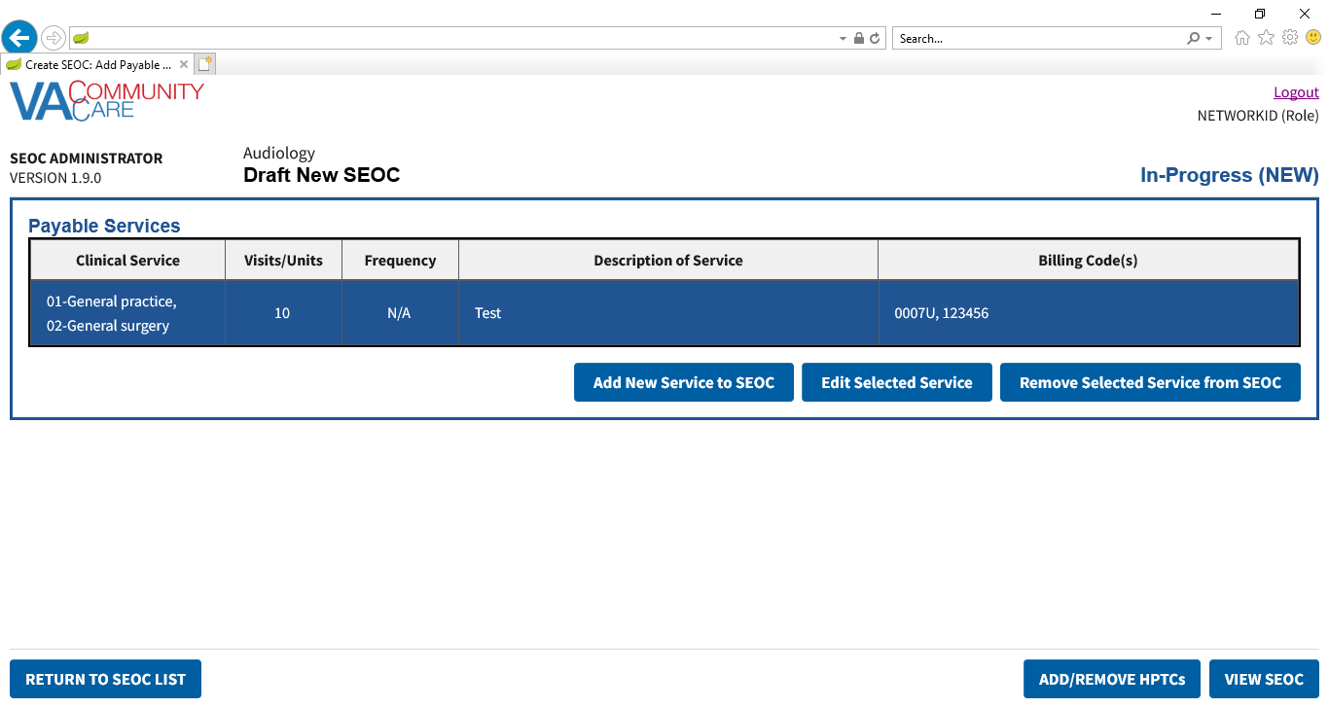

1. If any of the required fields are not populated, or if **Allowable Visits/Units** or **Frequency** are not numbers within the specified range, an error message will appear when you click **Done**.
2. If needed, you can select a **Payable Service** row and click **Remove Selected Service from SEOC** to remove a **Payable Service**. The **Confirm Delete Payable Service** dialog will display. Click **Confirm Deletion** to remove the **Payable Service**.

Figure 63: Draft SEOC: Delete Payable Service Confirmation

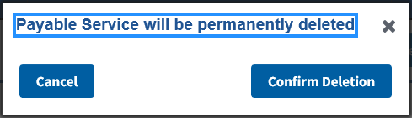

1. You can also select a **Payable Service** row and click **Edit Payable Service** to edit the selected **Payable Service**.
2. Click **View SEOC**. The information you entered will be displayed, including **Provider Taxonomy Codes (HPTCs)** and **Payable Services**. The **In-Progress (New)** status will display in the window.

Figure 64: Draft SEOC View

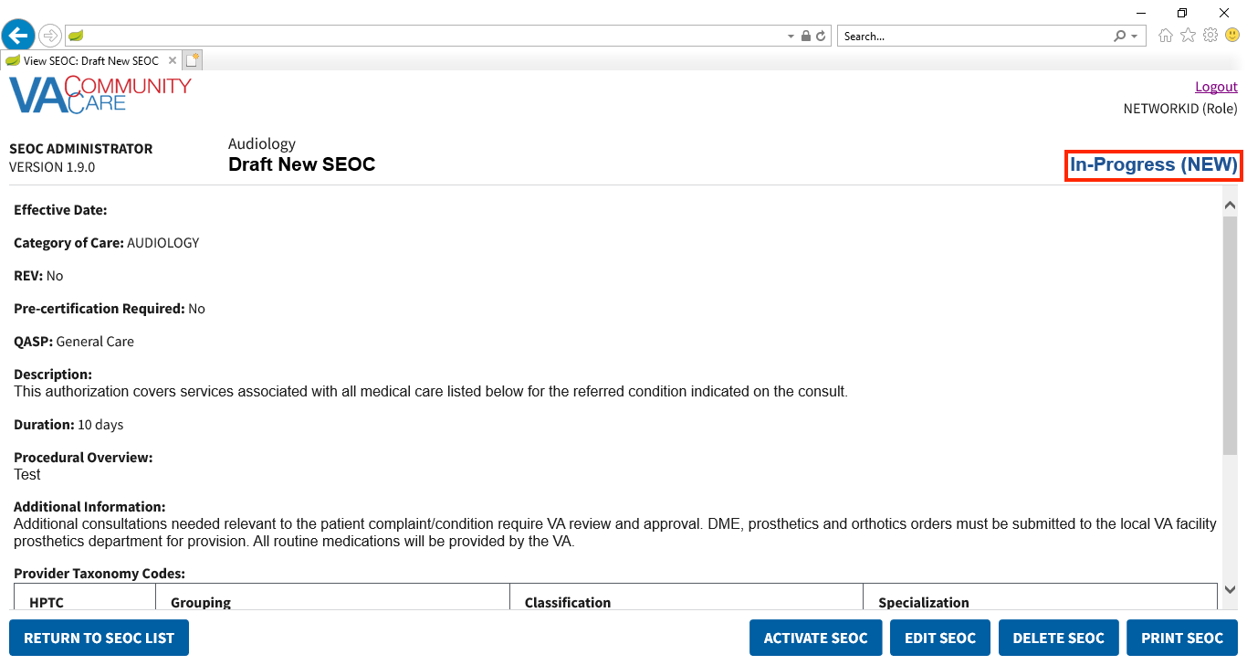

Figure 65: Draft SEOC: View Provider Taxonomy Codes and Payable Services

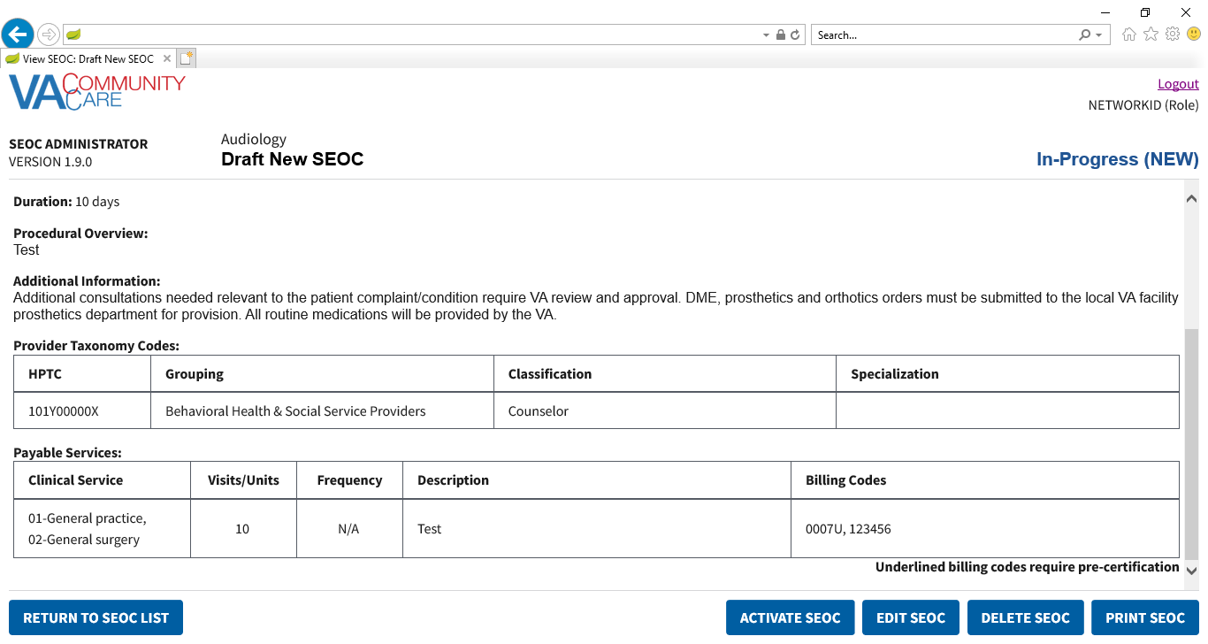

### Edit an In-Progress SEOC

1. If a user attempts to edit a SEOC that another user is already editing, the user will receive a message stating that the request can’t be processed.
2. If a user attempts to edit a SEOC while the system is in maintenance mode for Billing Code Management, the user will receive a message stating that the request can’t be processed.

To edit a SEOC that is currently marked as In-Progress, follow the steps listed below:

1. From the SEOC Admin home page, select the SEOC you would like to edit.
2. Click **View Selected SE**OC, the **View SEOC** page displays.
3. Click **EDIT SEOC**. The **Edit SEOC: Name** window displays.
4. Follow the workflow in the previous section to edit any fields as necessary.
5. Click **View SEOC** to confirm the edits.

### Activate an In-Progress SEOC

To activate a SEOC that is currently marked as In-Progress, follow the steps listed below:

1. From the SEOC Admin home page, select the SEOC you would like to activate.
2. Click **View Selected SEOC**, the **View SEOC** page displays.
3. Click **Activate SEOC**.
4. Once the SEOC is activated, the previous version status is automatically set to Discontinued.
5. If there are activation errors, the **Activation Error** dialog will display listing what needs to be resolved before the **SEOC** can be activated.

Figure 66: SEOC Activation Errors

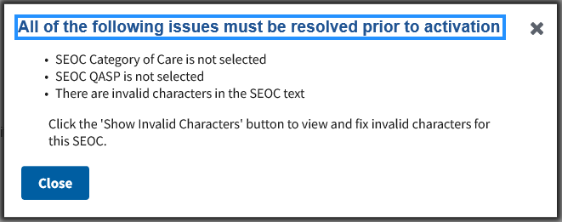

1. If there are no activation errors, the **Confirm Activation** dialog displays.

Figure 67: SEOC Activation Confirmation

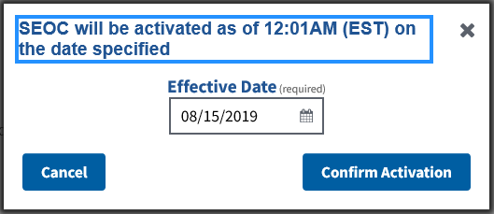

1. The **Effective Date** will default to the next day at 12:01AM EST. If needed, enter a new **Effective Date** in the input or click the calendar icon to select a date.

Figure 68: SEOC Activation Confirmation Calendar

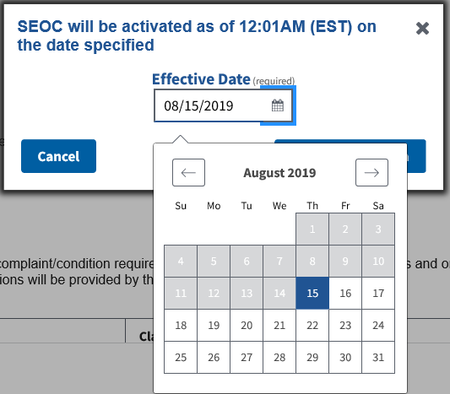

1. Click **Confirm Activation**. A confirmation message will display. The **Date Hold** status will display in the upper-right-hand corner of the page.

Figure 69: SEOC Will be Activated Message

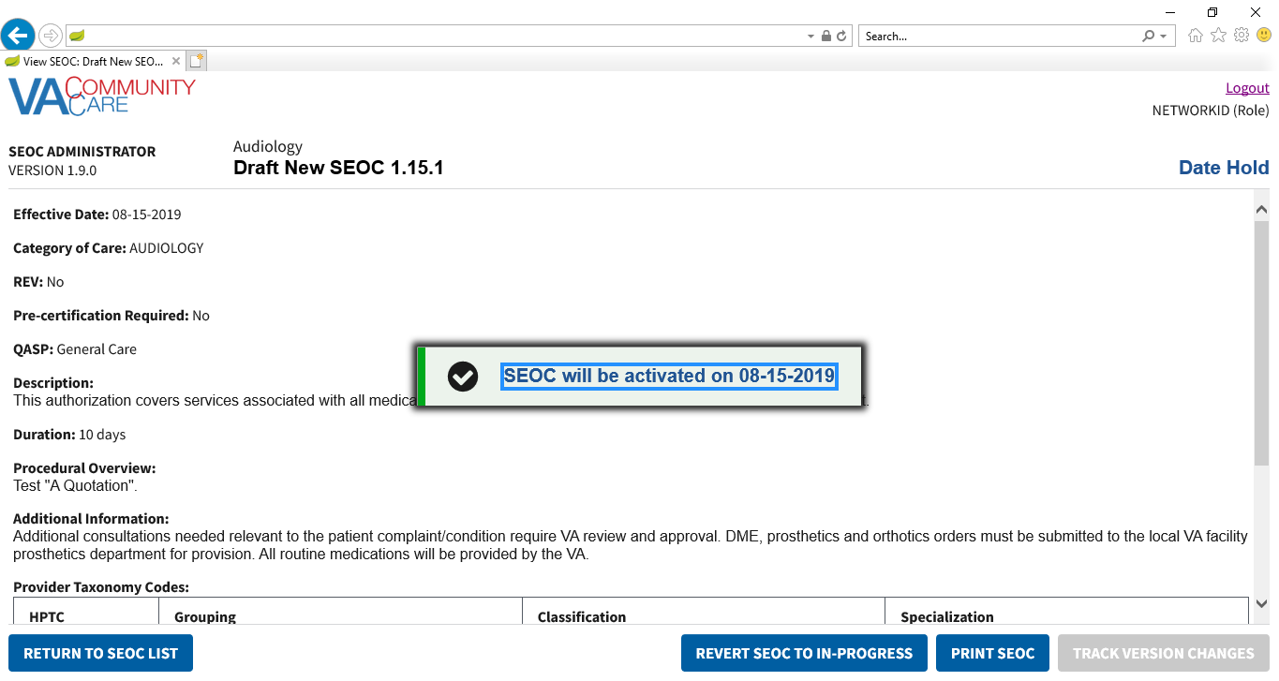

1. The **SEOC** will remain in **Date Hold** status until 12:01 AM EST on the specified **Effective Date**. At that time, the **SEOC** will change to **Active** status.

Figure 70: Date Hold Status

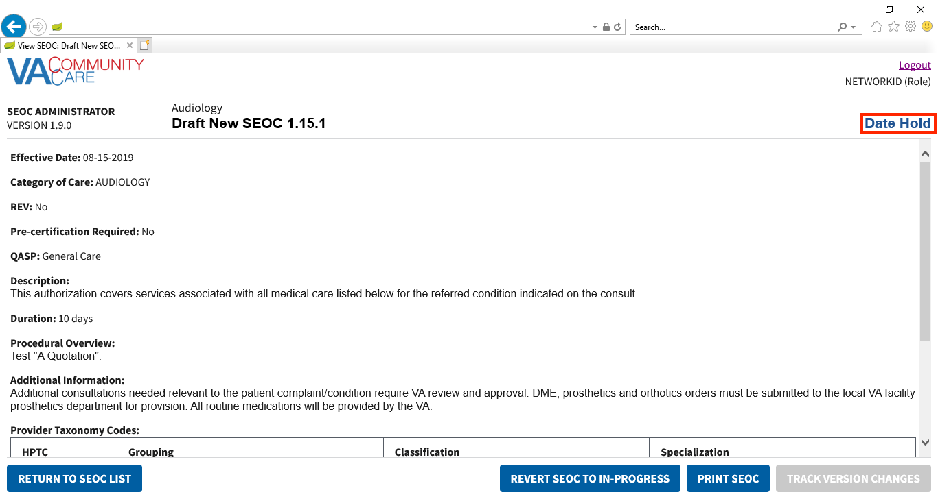

### Delete an In-Progress SEOC

To delete a SEOC that is currently marked as In-Progress, follow the steps listed below:

1. From the SEOC Admin home page, select the draft SEOC you would like to delete.
2. Click **View Selected SE**OC, the **View SEOC** page displays.
3. Click **Delete SEOC**. The **Confirm Deletion** dialog box displays.

Figure 71: Confirm Deletion

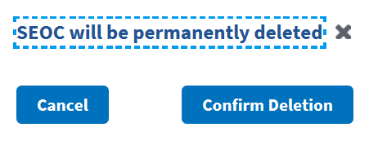

1. Click **Confirm Deletion**. The SEOC is deleted from the SEOC List.

## Pending Revisions

### Create a Pending Revision

To create a pending revision to an existing SEOC, follow the steps listed below:

1. From the SEOC Admin home page, select the active SEOC you would like to create a pending revision.
2. Click **View Selected SE**OC, the **View SEOC** page displays.
3. Click **Create Pending Revision**. The **Pending Revision: Name** window displays.

Figure 72: Pending Revision: Name

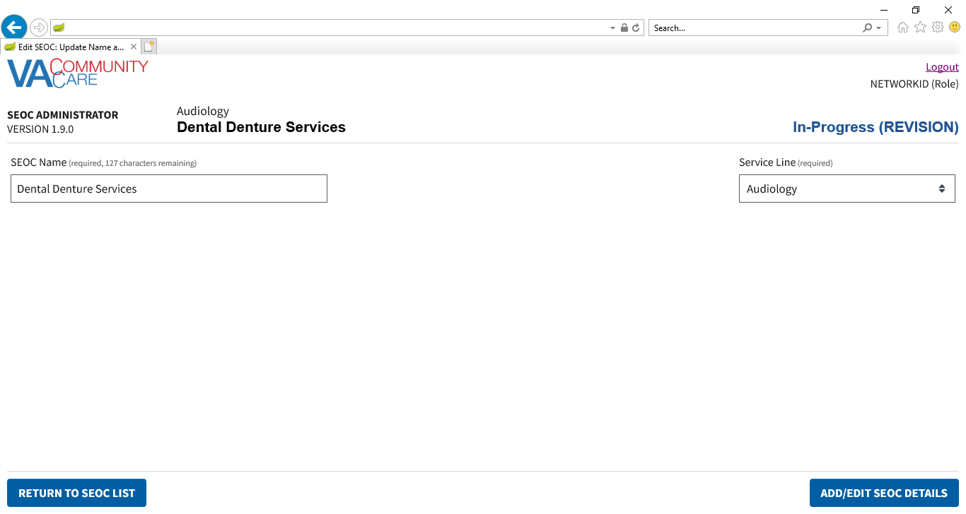

1. To return to the SEOC Admin home page while editing a new **SEOC** or **Revision**, click **Return to SEOC List** in the bottom left-hand corner of any page in the **Edit SEOC** workflow.
2. Update the **SEOC Name** and **Service Line** as needed.
3. Click **Add/Edit SEOC Details**. The **Pending Revision: Details** window displays.

Figure 73: Pending Revision: Details

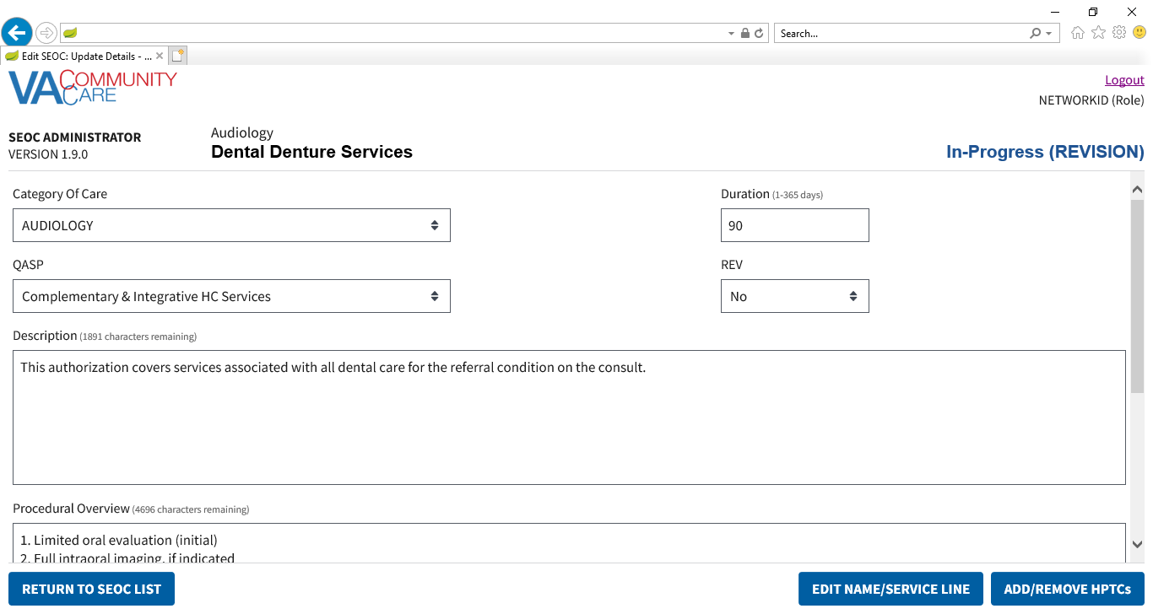

1. Update the details for the SEOC as needed.
2. Click **Add/Remove HPTCs**. The **Pending Revision: SEOC Provider Taxonomy Codes** window displays.

Figure 74: Pending Revision: SEOC Provider Taxonomy Codes

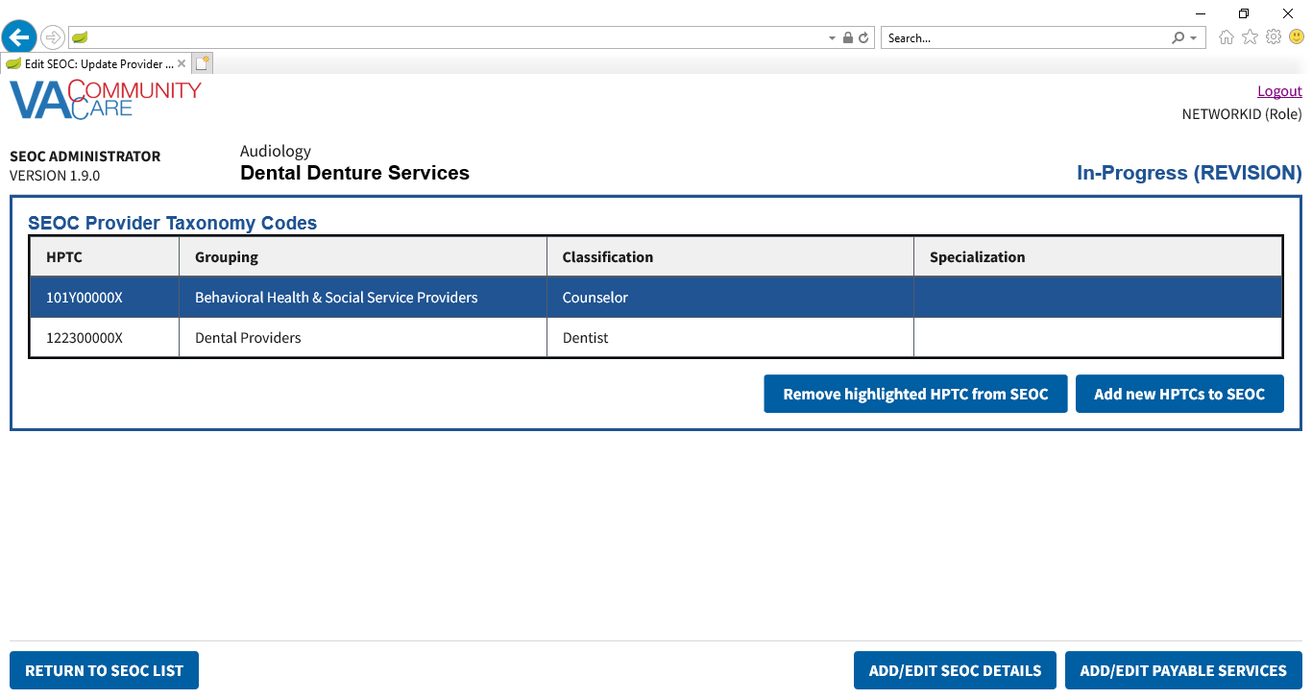

1. Update the **Provider Taxonomy Codes (HPTCs)** for the **SEOC** as needed.
2. Click **Add/Edit Payable Services**. The **Pending Revision: Payable Services** window displays.

Figure 75: Pending Revision: Payable Services

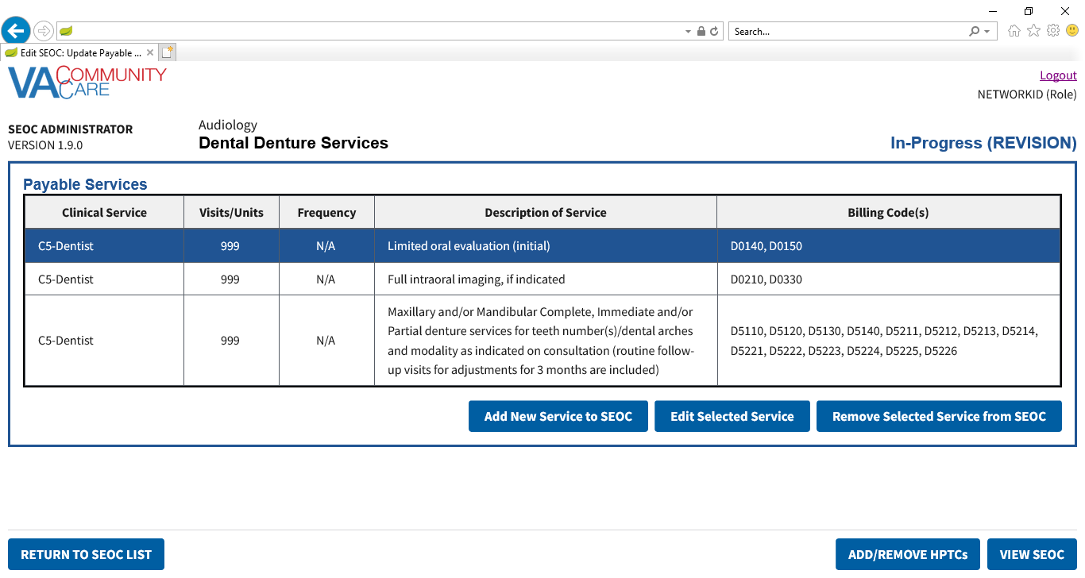

1. Update the **Payable Services** as needed.
2. Click **View SEOC**. The Pending Revision status will display in the window.

Figure 76: Pending Revision Status

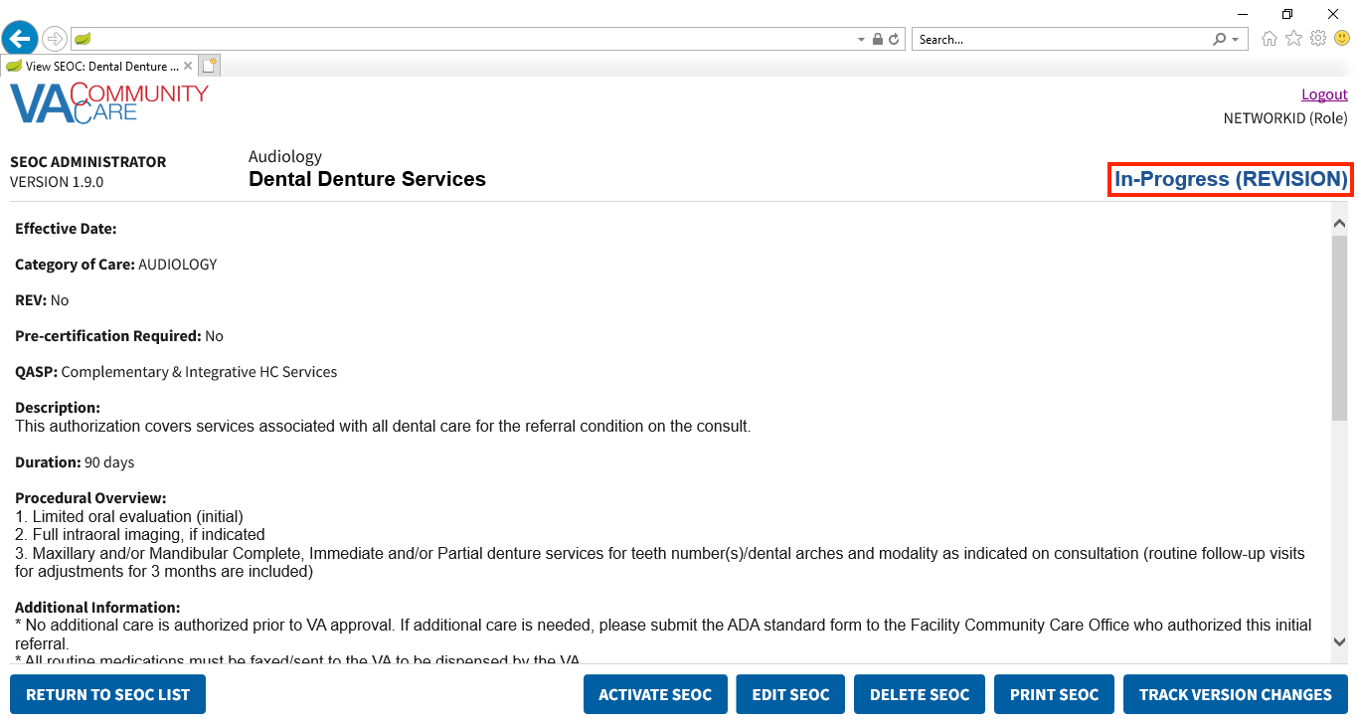

1. Click **Return to SEOC List**. The pending revision will display in the list of SEOCs.

Figure 77: Pending Revision Displayed in SEOC List

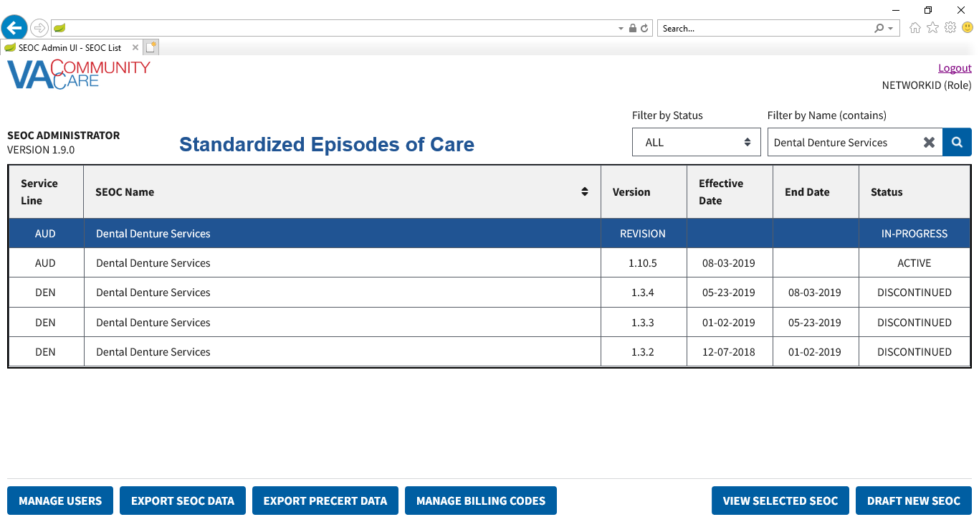

### Activate a Pending Revision

To activate a pending revision, follow the steps listed below:

1. From the SEOC Admin home page, select the **Revision** **SEOC** that you would like to activate.
2. Click **View Selected SE**OC, the **View SEOC** page displays.
3. Click **Activate SEOC**.
4. If there are activation errors, the **Activation Error** dialog will display listing what needs to be resolved before the **SEOC** can be activated.

Figure 78: Revision Activation Errors

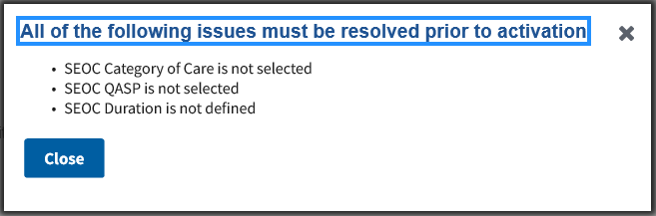

1. The **Confirm Activation** dialog will display.

Figure 79: Pending Revision Activation Confirmation Message

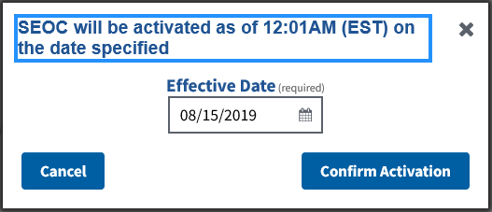

1. The **Effective Date** will default to the next day at 12:01AM EST. If needed, enter a new **Effective Date** in the input or click the calendar icon to select a date.

Figure 80: Revision Activation Confirmation Date Calendar

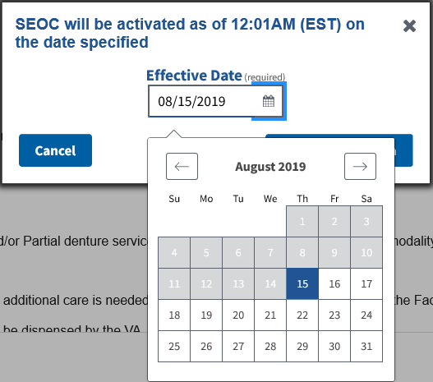

1. Click **Confirm Activation**. A confirmation message will display. The **Date Hold** **Status** will display in the upper-right-hand corner of the page.

Figure 81: Revision Will be Activated Message

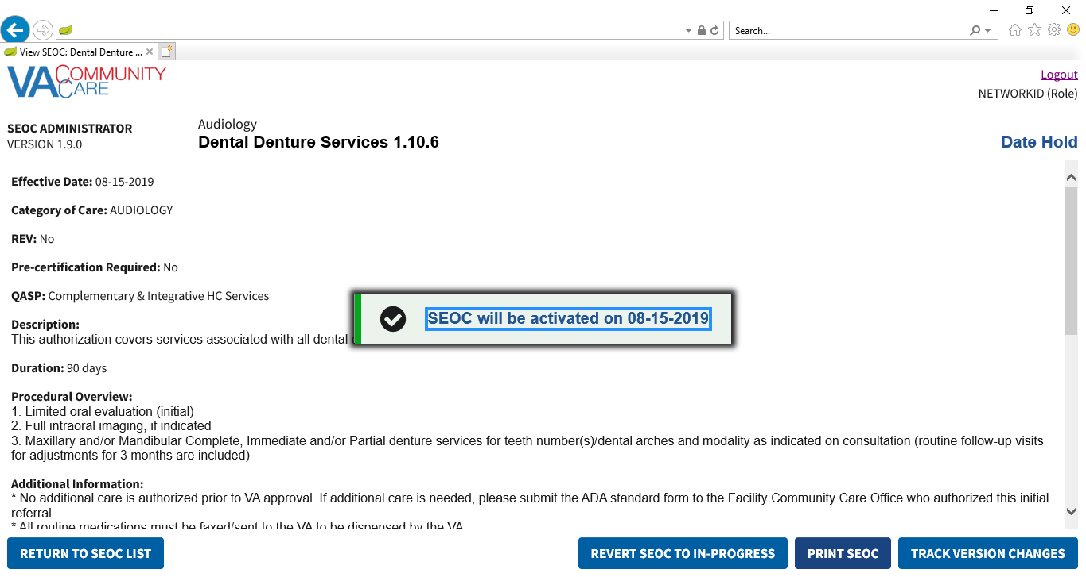

Figure 82: Date Hold Status

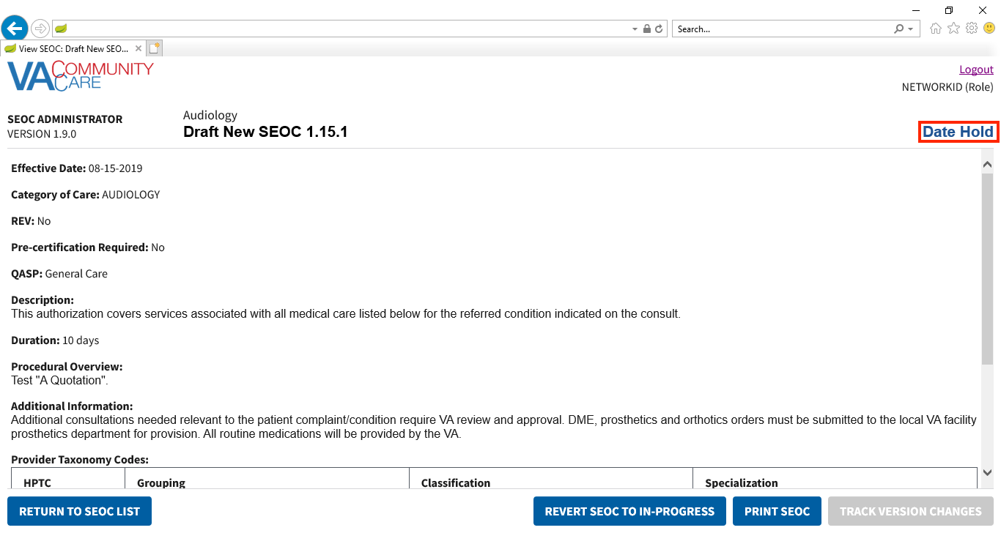

1. Click **Return to SEOC List**. The pending revision that you just activated will display as **Date Hold** in the list of SEOCs.
2. The **Revision** will remain in **Date Hold** status and the previous **SEOC** will remain in **Active** status until 12:01 AM EST on the specified **Effective Date**. At that time, the **Revision** will change to **Active** status and the previous **SEOC** will change to **Discontinued** status.

### Revert a Date Hold SEOC back to In-Progress

If you need to revert the selected SEOC to In-Progress, follow the steps listed below:

1. From the SEOC Admin home page, select the **Date Hold SEOC** you would like to revert back to **In-Progress**.
2. Click **View Selected SEOC**, the **View SEOC** page displays.
3. Click **Revert SEOC to In-Progress**. The **Confirm Revert SEOC to In-Progress** dialog will display.

Figure 83: Confirm Revert SEOC to In-Progress

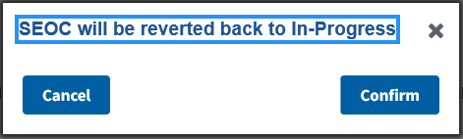

1. Click **Confirm**. The **SEOC** will be reverted back to **In-Progress**.

## Payable Service List

### View Payable Services

To view the payable services for a selected SEOC, follow the steps listed below:

1. From the SEOC Admin home page, select the SEOC you would like to view the payable services for.
2. Click **View Selected SEOC**, the **View SEOC** page displays.
3. Scroll to the bottom of the page to view the Payable Services list.

Figure 84: View SEOC – Payable Services

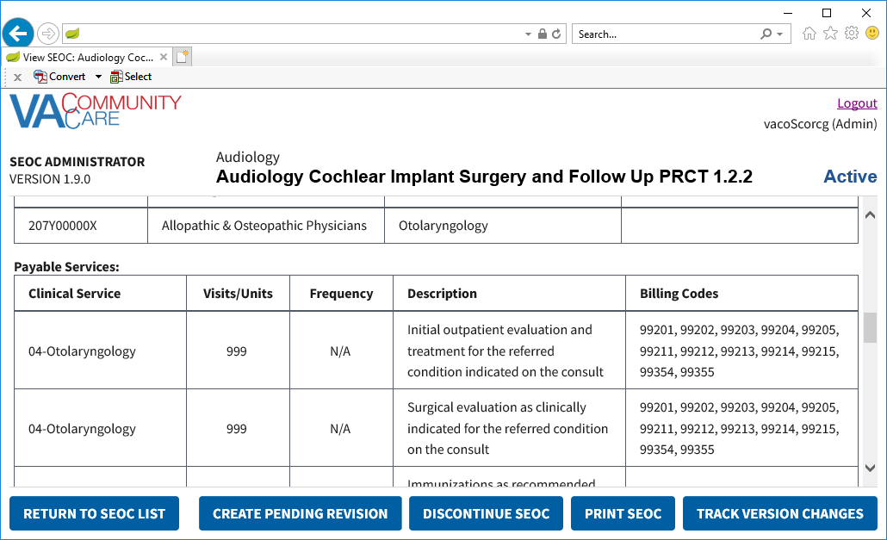

### Delete Payable Service

To delete payable services for a selected SEOC, follow the steps listed below:

1. From the SEOC Admin home page, select the SEOC you would like to view the payable services for.
2. Click **View Selected SE**OC, the **Standardized Episode of Care – Provider Information** page displays.
3. From the **View SEOC** page, click **Create Pending Revision**. The **Draft SEOC Name** window displays.
4. Click **Add/Edit SEOC Details**. The **Draft SEOC Details** window displays.
5. Click **Add/Remove HPTCs**. The **Add/Remove HPTCs** window displays.
6. Click **Add/Edit Payable Services**. The **Draft SEOC Payable Services** window displays.
7. From the list of payable services, select the payable service that you would like to delete.
8. Click **Remove Selected Service from SEOC**. A message will display confirming that you would like to delete the payable service from the SEOC.

Figure 85: Payable Service Confirm Deletion

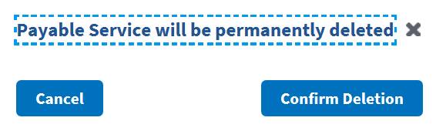

1. Click **Confirm Deletion**. The payable service is deleted from the list.

# Troubleshooting

Users may encounter the following errors while using the SEOC UI.

Table 2: SEOC Error Codes with Descriptions

| Error Code | Description |
| --- | --- |
| 204 | No Content Found |
| 401 | Unauthorized |
| 403 | Forbidden |
| 404 | Not Found |

# Acronyms and Abbreviations

| Acronym | Definition |
| --- | --- |
| CAC | Clinical Application Coordinators |
| CC | Care Coordination |
| CCAD | Community Care Agile Development |
| CDW | Corporate Data Warehouse |
| CID | Clinically Indicated Date |
| CPRS | Computerized Patient Record System |
| HEC | Health Eligibility Center |
| HPTC | Healthcare Provider Taxonomy Code |
| JSON | JavaScript Object Notification |
| NSD | National Service Desk |
| OIT | Office of Information and Technology |
| PCP | Primary Care Physician |
| SAR | Secondary Authorization Request |
| SEOC | Standardized Episode of Care |
| VA | Department of Veterans Affairs |
| VDL | VA Software Document Library |
| VistA | Veterans Health Information Systems and Technology Architecture |

1. JSON Instructions
2. The steps outlined below are for Excel 2016.

To convert the SEOC JSON file to an Excel file, follow the steps listed below:

1. Select to download the SEOC JSON file. The Internet Explorer File Download Prompt displays at the bottom of the window.
2. From the **Save** menu, select **Save as**. The **Save As** window displays.
3. Select to download the file to the Desktop and click **Save**.
4. Open a blank workbook in Excel 2016.
5. Click the **Data** tab, then **Get Data** > **From File** > **From JSON**. The **Import Data** window displays.

Figure 86: Import Data Window

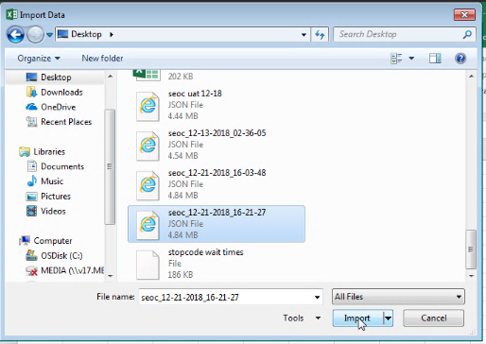

1. Select the JSON file you downloaded and click **Import**. Excel will open the file in the Query Editor.

Figure 87: Query Editor

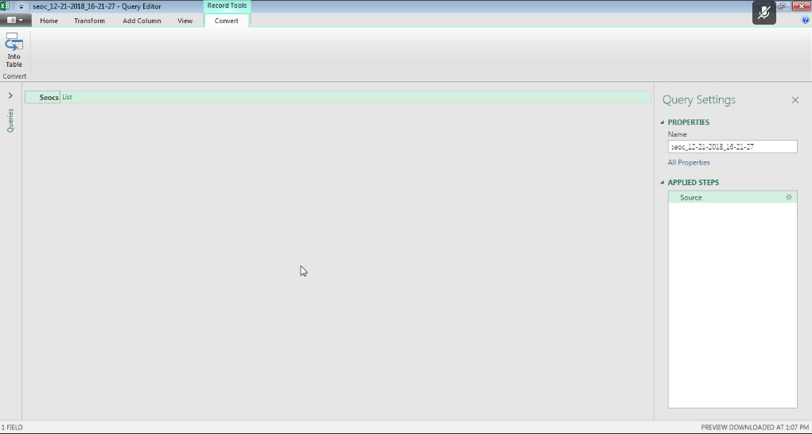

1. Click the **List** header to the right of **Seocs** to display a list of records.

Figure 88: List of Records

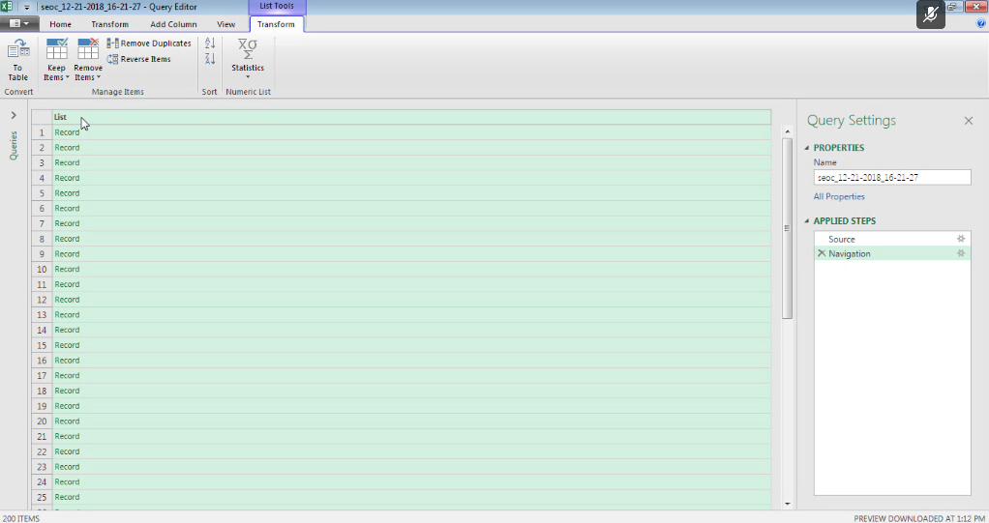

1. From the **Transform** tab, click the **Convert To Table** icon and click **OK**. The **To Table** dialog box displays.

Figure 89: To Table Dialog Box

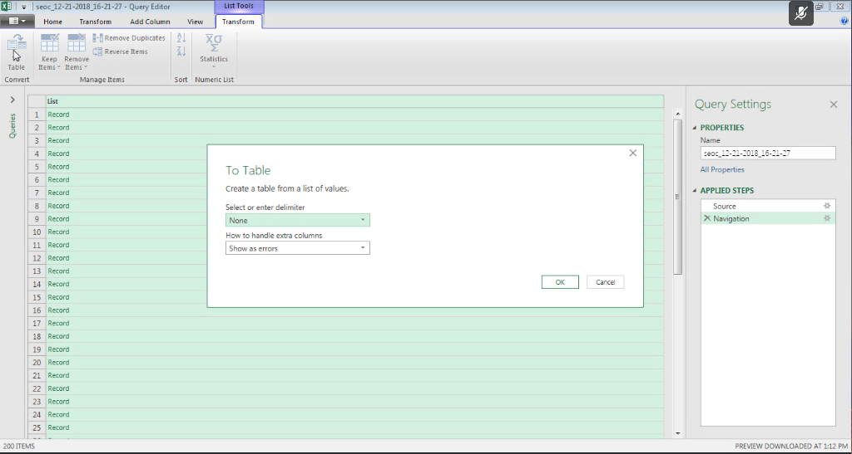

1. From the **To Tabl**e dialog box keep the default selections and click **OK**.
2. Click on the expand icon (<-||->) to the right of the **Column1** header to display the **Search Columns to Expand** dialog box.

Figure 90: Search Columns to Expand Dialog Box

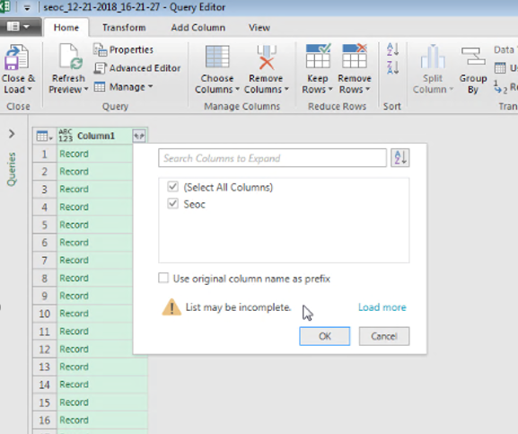

1. De-select the **Use original column name as prefix** check box.
2. Click **OK**.
3. Click on the expand icon (<-||->) to the right of the **Seoc** header to display the **Search Columns to Expand** dialog box.

Figure 91: Search Columns to Expand

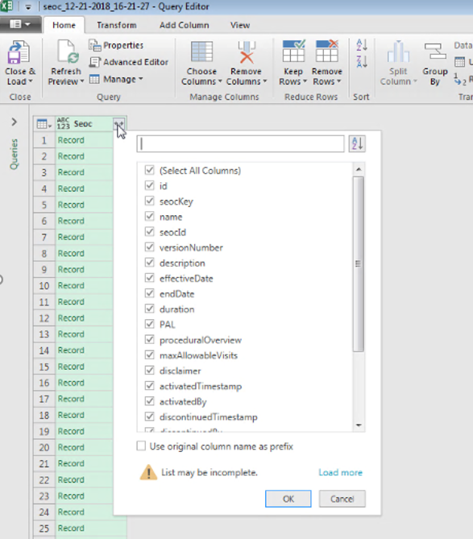

1. Uncheck the **Use original column name as prefix** check box.
2. Click **OK**. The fields in the SEOC table will be expanded to columns as shown below.

Figure 92: Expanded SEOC Fields

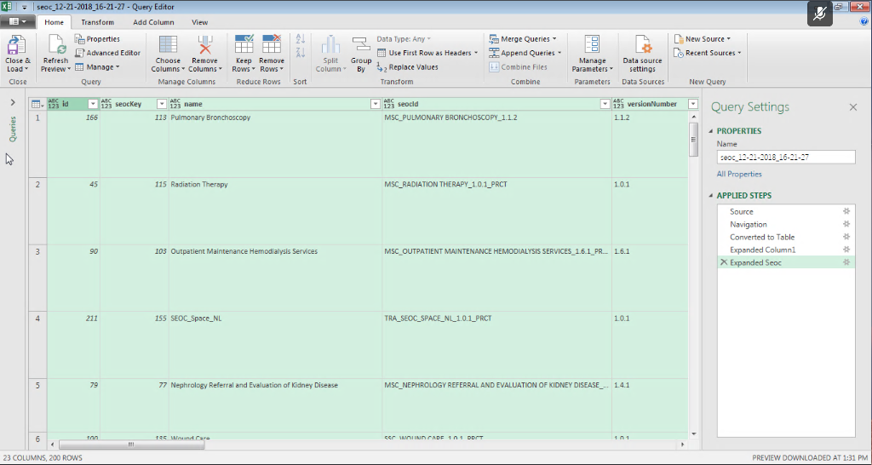

1. Scroll right to the **services** column, click on the expand icon, and select **Expand to New Rows** to display the records.

Figure 93: Expand to New Rows Menu Option

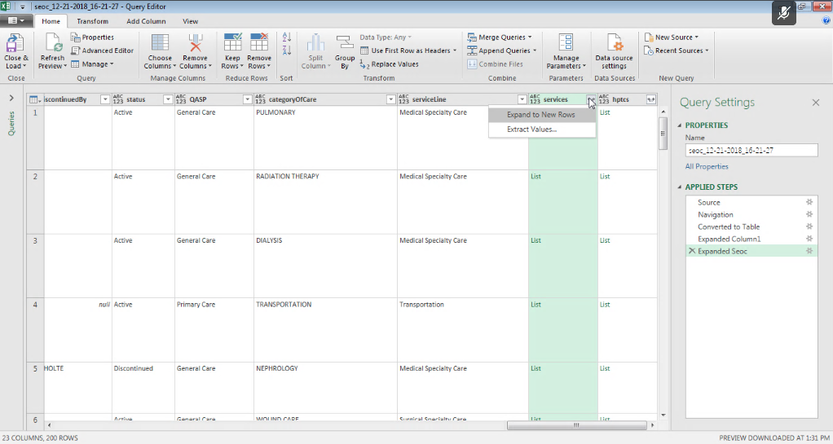

1. Click the expand icon again and press **OK** to expand the Payable Services fields into columns.

Figure 94: Payable Services Columns

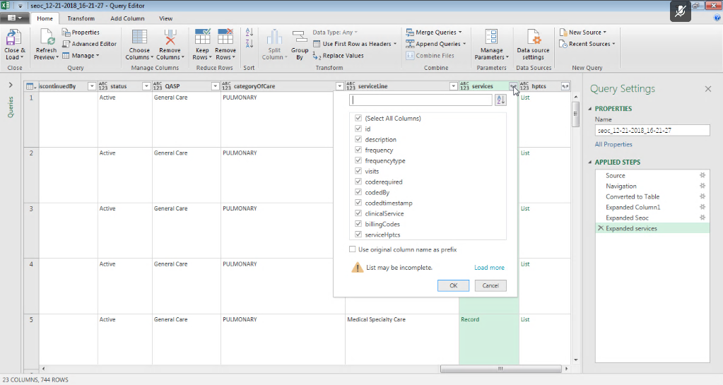

1. Scroll right to the **billingCodes** column and repeat the last two steps to expand the **Billing Code** fields into columns.

Figure 95: Billing Code Columns

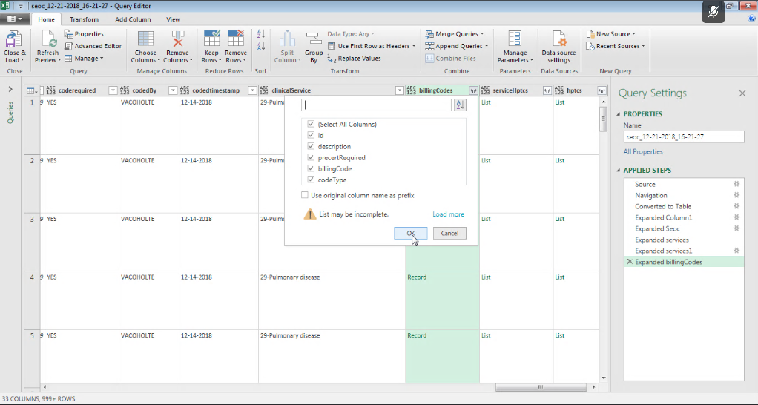

1. Optional - Repeat the last two steps again for the serviceHptcs column if you want to see the cross-walked HPTCs that are sent for each Payable Service.
2. Scroll right and repeat the last two steps again for the hptcs column to expand the HPTC fields that were assigned to each SEOC.

Figure 96: Expanded HPTC Fields

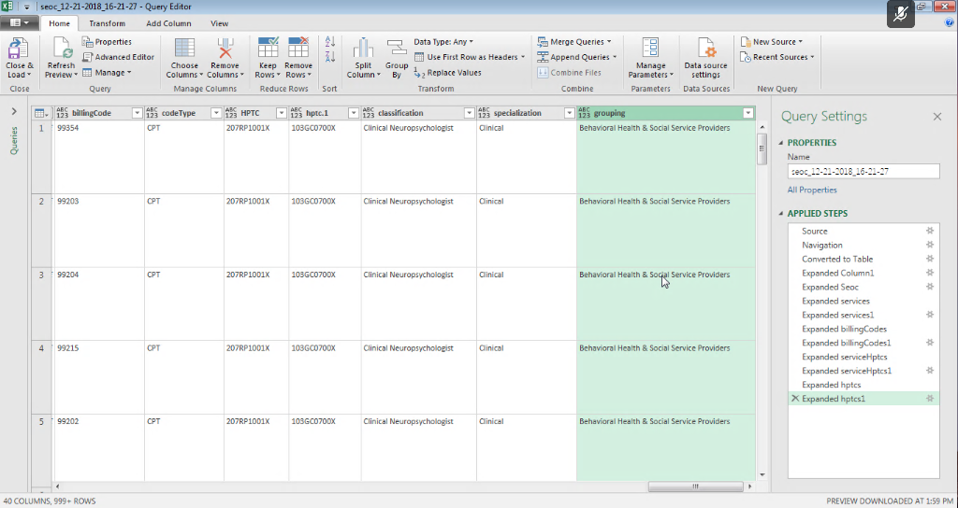

1. Click the **Close & Load** option at the left of the ribbon to create load the imported data into a spreadsheet tab.

Figure 97: Imported Data

